UNITED STATES
SECURITIES AND EXCHANGE COMMISSION
Washington, D.C. 20549

FORM 8-K

CURRENT REPORT
Pursuant to Section 13 or 15(d)
of the Securities Exchange Act of 1934
Date of Report (Date of earliest event reported): July 17, 2026

KALARIS THERAPEUTICS, INC.
(Exact name of registrant as specified in its charter)

Delaware |  | 001-39409 |  | 83-1971007
(State or other jurisdiction  of incorporation) |  | (Commission  File Number) |  | (I.R.S. Employer  Identification No.)
Kalaris Therapeutics, Inc.
400 Connell Drive, Suite 5500
Berkeley Heights, New Jersey 07922
(Address of principal executive offices, including zip code)
(650) 249-2727
(Registrant’s telephone number, including area code)
Not applicable
(Former Name or Former Address, if Changed Since Last Report)

Check the appropriate box below if the Form 8-K filing is intended to simultaneously satisfy the filing obligation of the registrant under any of the following provisions:

☐ | Written communications pursuant to Rule 425 under the Securities Act (17 CFR 230.425)

☐ | Soliciting material pursuant to Rule 14a-12 under the Exchange Act (17 CFR 240.14a-12)

☐ | Pre-commencement communications pursuant to Rule 14d-2(b) under the Exchange Act (17 CFR 240.14d-2(b))

☐ | Pre-commencement communications pursuant to Rule 13e-4(c) under the Exchange Act (17 CFR 240.13e-4(c))
Securities registered pursuant to Section 12(b) of the Act:

Title of each class |  | Trading  Symbol(s) |  | Name of each exchange  on which registered
Common Stock, $0.0001 par value per share |  | KLRS |  | The Nasdaq Global Market
Indicate by check mark whether the registrant is an emerging growth company as defined in Rule 405 of the Securities Act of 1933 (§ 230.405 of this chapter) or Rule 12b-2 of the Securities Exchange Act of 1934 (§ 240.12b-2 of this chapter).
Emerging growth company ☐
If an emerging growth company, indicate by check mark if the registrant has elected not to use the extended transition period for complying with any new or revised financial accounting standards provided pursuant to Section 13(a) of the Exchange Act. ☐

Item 7.01. | Regulation FD Disclosure.
On July 17, 2026, Kalaris Therapeutics, Inc. (the “Company”) issued a press release announcing positive additional data from its Phase 1a single ascending dose (“SAD”) clinical trial of TH103 in treatment-naïve patients with neovascular age-related macular degeneration (“nAMD”) from expanded cohorts. The press release is attached hereto as Exhibit 99.1 and is incorporated herein by reference.
In addition, on July 17, 2026, the Company made available an updated corporate presentation that it plans to use for upcoming meetings with investors and analysts. A copy of the presentation is attached hereto as Exhibit 99.2 and is incorporated herein by reference.
The information in this Item 7.01, including Exhibit 99.1 and Exhibit 99.2 attached hereto, is being furnished and shall not be deemed “filed” for purposes of Section 18 of the Securities Exchange Act of 1934, as amended (the “Exchange Act”), or otherwise subject to the liabilities of that section, nor shall it be deemed incorporated by reference in any filing under the Securities Act of 1933, as amended, or the Exchange Act, except as expressly set forth by specific reference in such a filing.

Item 8.01. | Other Events.
On July 17, 2026, the Company issued a press release announcing positive additional data from its Phase 1a SAD clinical trial of TH103 in treatment-naïve patients with nAMD. Data from the expanded cohorts build on previously reported positive findings from the trial, with additional patients showing improvements in vision and retinal anatomy and further supporting the potential for extended treatment durability after a standard four-dose loading regimen.
The expanded Phase 1a SAD dataset now includes a total of 17 treatment-naive patients, as well as an additional three treatment-experienced patients which were included in the safety cohort. All 20 patients completed six months of follow up. Consistent with the Company’s previously reported findings, the expanded efficacy analysis, which includes the 17 treatment-naïve patients, continued to demonstrate robust structural and functional improvements.
TH103 plasma pharmacokinetic findings continued to suggest greater intraocular retention, with 27- to 53-fold lower Cmax compared to current leading anti-vascular endothelial growth factor (“VEGF”) agents on a molar equivalence basis. Additionally, the time to retreatment results further supported the hypothesis that increased intraocular retention may contribute to prolonged biological activity: following only a single TH103 injection, 41% of treatment-naïve patients (N=17) received a first retreatment at four months or later, 35% at five months or later, and 29% received no additional anti-VEGF treatment during the entire six-month follow-up period. Separately, after a single TH103 injection, time to retreatment in treatment-experienced patients (N=3) was extended by an average of two months compared with prior anti-VEGF treatment intervals.
In addition, data from the Phase 1a SAD clinical trial demonstrated a rapid, robust response in best corrected visual acuity (“BCVA”) and optical coherence tomography (OCT) parameters across dose levels at one month in treatment-naïve patients:

 | • |  | Mean 9.2-letter BCVA improvement after one TH103 injection; and

 | • |  | Mean 118µm improvement in mean central subfield thickness and mean 93% reduction in central subfield intraretinal fluid.
No cases of intraocular inflammation (“IOI”) were observed among the six patients treated at the 2.5 mg dose using product manufactured following process adjustments to reduce impurities. As previously reported, one patient treated at the 5 mg dose experienced transient IOI that resolved without sequelae.
Building on these findings, the Company is actively enrolling and dosing patients in its ongoing Phase 1b/2 study aimed at evaluating a standard four-dose loading regimen of TH103 in treatment-naïve patients using an ascending-dose design. The study is designed to evaluate the safety, tolerability, pharmacokinetics and preliminary efficacy of repeated TH103 intravitreal injections as well as time to retreatment following a complete loading course. Study results will inform dose selection for potential future Phase 3 trials of TH103, and the Company remains on-track to share initial data from the Phase 1b/2 study in the first half of 2027.
Forward-Looking Statements
This Current Report on Form 8-K contains “forward-looking statements” within the meaning of the U.S. Private Securities Litigation Reform Act of 1995 and Section 21E of the Exchange Act that involve substantial risk and uncertainties. All statements, other than statements of historical fact, contained in this Current Report on Form 8-K, including statements regarding the strategy, future operations, prospects, plans and objectives of management of the

Company; the therapeutic potential of TH103 for nAMD and other exudative and neovascular retinal diseases; the anticipated timeline for reporting data from the ongoing Phase 1b/2 clinical trial of TH103; plans to advance TH103 into Phase 3 clinical trials and to develop TH103 for additional indications, plans to improve the manufacturing process for TH103 and the sufficiency of the Company’s cash resources for the period anticipated, are forward-looking statements. The words “anticipate,” “believe,” “continue,” “could,” “estimate,” “expect,” “intend,” “may,” “might,” “plan,” “potential,” “predict,” “project,” “should,” “target,” “would” and similar expressions are intended to identify forward-looking statements, although not all forward-looking statements contain these identifying words. These statements are based on current expectations and beliefs of the management of the Company as well as assumptions made by, and information currently available to, the management of the Company and are subject to risks and uncertainties. There can be no assurance that future developments affecting the Company will be those that it has anticipated. Actual results or events could differ materially from the plans, intentions and expectations disclosed in these forward-looking statements as a result of various important factors, including: risks associated with the clinical development and regulatory approval of TH103, including potential delays in the completion of clinical trials; expectations regarding the therapeutic benefits, clinical potential and clinical development of TH103; the timing of and the Company’s ability to enroll patients in clinical trials; whether results from preclinical studies and initial data from early clinical trials will be predictive of the final results of the clinical trials or future trials; dependence on third parties for the development and manufacture of TH103; risks related to the inability of the Company to obtain sufficient additional capital to continue to advance its product candidate; uncertainties in obtaining successful clinical results for product candidates and unexpected costs that may result therefrom; the ability to obtain, maintain, and protect intellectual property rights related to product candidates; changes in regulatory requirements and government incentives; the Company’s competitive position and expectations regarding developments and projections relating to its competitors and any competing therapies that are or become available; the risk of involvement in current and future litigation; and such other factors as are set forth in the Company’s public filings with the Securities and Exchange Commission, including, but not limited to, those described under the heading “Risk Factors”. The Company may not actually achieve the plans, intentions or expectations disclosed in its forward-looking statements, and you should not place undue reliance on its forward-looking statements. The forward-looking statements contained in this Current Report on Form 8-K are made as of the date of this Current Report on Form 8-K, and the Company does not assume any obligation to update any forward-looking statements, whether as a result of new information, future events or otherwise, except as required by applicable law.

Item 9.01. | Financial Statements and Exhibits.
(d) Exhibits:

Exhibit  No. |  | Description
99.1 |  | Press Release, dated July 17, 2026
99.2 |  | Presentation, dated July 17, 2026
104 |  | Cover Page Interactive Data File (embedded within the Inline XBRL document).

SIGNATURES
Pursuant to the requirements of the Securities Exchange Act of 1934, the registrant has duly caused this report to be signed on its behalf by the undersigned hereunto duly authorized.

 |  |  |  | KALARIS THERAPEUTICS, INC.
Date: July 17, 2026 |  |  |  | By: |  | /s/ Andrew Oxtoby
 |  |  |  | Name: |  | Andrew Oxtoby
 |  |  |  | Title: |  | Chief Executive Officer
Exhibit 99.1


Kalaris Therapeutics Reports Positive TH103 Phase 1a SAD Results from Expanded Neovascular AMD Cohorts
Data from the expanded cohorts reinforce the positive BCVA, OCT, pharmacokinetic and time-to-retreatment findings observed in the original cohorts
Enrollment in the Phase 1b/2 multiple-ascending dose trial of TH103 continues, with preliminary data on track for 1H 2027
BERKELEY HEIGHTS, N.J., July 17, 2026 (GLOBE NEWSWIRE) — Kalaris Therapeutics, Inc. (Nasdaq: KLRS) (“Kalaris”), a clinical-stage biopharmaceutical company dedicated to the development and commercialization of treatments for prevalent retinal diseases, today announced positive additional data from its Phase 1a single ascending dose (SAD) trial of TH103 in neovascular age-related macular degeneration (AMD). Data from the expanded cohorts build on previously reported positive findings from the trial, with additional patients showing improvements in vision and retinal anatomy and further supporting the potential for extended treatment durability after a standard four-dose loading regimen. The updated SAD results will be presented today at 8:00 am EDT by Dr. Joel Pearlman, MD, PhD, at the American Society of Retina Specialists (ASRS) Annual Meeting.
The expanded Phase 1a SAD dataset now includes a total of 17 treatment-naive patients, as well as an additional 3 treatment-experienced patients which were included in the safety cohort. All 20 patients completed six months of follow-up. Consistent with Kalaris’ previously reported findings, the expanded efficacy analysis, which includes the 17 treatment-naïve patients, continued to demonstrate robust structural and functional improvements.
TH103 plasma pharmacokinetic findings continued to suggest greater intraocular retention, with 27- to 53-fold lower Cmax compared to current leading anti-VEGF agents on a molar equivalence basis. Additionally, the time to retreatment results further supported the hypothesis that increased intraocular retention may contribute to prolonged biological activity: following only a single TH103 injection, 41% of treatment-naïve patients (N=17) received a first retreatment at 4 months or later, 35% at 5 months or later, and 29% received no additional anti-VEGF treatment during the entire six-month follow-up period. Separately, after a single TH103 injection, time to retreatment in treatment-experienced patients (N=3) was extended by an average of 2 months compared with prior anti-VEGF treatment intervals.

No cases of intraocular inflammation (IOI) were observed among the six patients treated at the 2.5 mg dose using product manufactured following process adjustments to reduce impurities. As previously reported, one patient treated at the 5 mg dose experienced transient IOI that resolved without sequelae.
“The expanded Phase 1a SAD dataset continues to strengthen our confidence in potential TH103 differentiation,” said Andrew Oxtoby, CEO of Kalaris Therapeutics. “The consistency of the structural, functional and pharmacokinetic findings reinforces our belief that TH103 has the potential to offer a best-in-class treatment option for patients with neovascular AMD.”
Building on these findings, Kalaris is actively enrolling and dosing patients in its ongoing Phase 1b/2 study aimed at evaluating a standard four-dose loading regimen of TH103 in treatment-naïve patients using an ascending-dose design. The study is designed to evaluate the safety, tolerability, pharmacokinetics and preliminary efficacy of repeated TH103 intravitreal injections as well as time to retreatment following a complete loading course. Study results will inform dose selection for potential future Phase 3 trials of TH103, and Kalaris remains on track to share initial data from the Phase 1b/2 study in the first half of 2027.
About TH103
TH103 is a potential best-in-class, investigational dual-targeting biologic engineered by VEGF scientific discoverer Dr. Napoleone Ferrara to achieve extended intraocular retention with enhanced VEGF inhibition through optimized binding to VEGF receptor 1 ligands and concurrent heparan sulfate proteoglycan (HSPG) anchoring. It is a fully humanized, recombinant fusion protein designed for intravitreal delivery, with potential applications as a treatment for exudative and/or neovascular retinal diseases, such as neovascular AMD, diabetic eye disease and retinal vein occlusion. TH103 is currently being investigated in a Phase 1b/2 clinical trial in patients with neovascular Age-related Macular Degeneration (nAMD).
About Kalaris
Kalaris Therapeutics is a clinical-stage biopharmaceutical company dedicated to the development and commercialization of treatments for prevalent retinal diseases. Founded by renowned scientist Dr. Napoleone Ferrara, whose pioneering research led to the development of anti-VEGF therapy, the company is committed to advancing novel therapeutic approaches for patients with sight-threatening retinal conditions with major unmet medical needs.

For more information, visit www.kalaristx.com.
Forward Looking Statements
This press release contains “forward-looking statements” within the meaning of the U.S. Private Securities Litigation Reform Act of 1995 and Section 21E of the Securities Exchange Act of 1934, as amended, that involve substantial risk and uncertainties. All statements, other than statements of historical fact, contained in this press release, including statements regarding the strategy, future operations, prospects, plans and objectives of management of Kalaris; the therapeutic potential of TH103 for neovascular Age-related Macular Degeneration and other exudative and neovascular retinal diseases; the anticipated timeline for reporting data from the ongoing Phase 1b/2 clinical trial of TH103; plans to advance TH103 into Phase 3 clinical trials and to develop TH103 for additional indications, plans to improve the manufacturing process for TH103 and the sufficiency of Kalaris’ cash resources for the period anticipated, are forward-looking statements. The words “anticipate,” “believe,” “continue,” “could,” “estimate,” “expect,” “intend,” “may,” “might,” “plan,” “potential,” “predict,” “project,” “should,” “target,” “would” and similar expressions are intended to identify forward-looking statements, although not all forward-looking statements contain these identifying words. These statements are based on current expectations and beliefs of the management of Kalaris as well as assumptions made by, and information currently available to, the management of Kalaris and are subject to risks and uncertainties. There can be no assurance that future developments affecting Kalaris will be those that it has anticipated. Actual results or events could differ materially from the plans, intentions and expectations disclosed in these forward-looking statements as a result of various important factors, including: risks associated with the clinical development and regulatory approval of TH103, including potential delays in the completion of clinical trials; expectations regarding the therapeutic benefits, clinical potential and clinical development of TH103; the timing of and Kalaris’ ability to enroll patients in clinical trials; whether results from preclinical studies and initial data from early clinical trials will be predictive of the final results of the clinical trials or future trials; dependence on third parties for the development and manufacture of TH103; risks related to the inability of Kalaris to obtain sufficient additional capital to continue to advance its product candidate; uncertainties in obtaining successful clinical results for product candidates and unexpected costs that may result therefrom; the ability to obtain, maintain,

and protect intellectual property rights related to product candidates; changes in regulatory requirements and government incentives; Kalaris’ competitive position and expectations regarding developments and projections relating to its competitors and any competing therapies that are or become available; the risk of involvement in current and future litigation; and such other factors as are set forth in Kalaris’ public filings with the SEC, including, but not limited to, those described under the heading “Risk Factors”. Kalaris may not actually achieve the plans, intentions or expectations disclosed in its forward-looking statements, and you should not place undue reliance on its forward-looking statements. The forward-looking statements contained in this press release are made as of the date of this press release, and Kalaris does not assume any obligation to update any forward-looking statements, whether as a result of new information, future events or otherwise, except as required by applicable law.
Kalaris Therapeutics Investor Contact:
Corey Davis, Ph.D.
LifeSci Advisors, LLC
+1 212 915 2577
cdavis@lifesciadvisors.com
ir@kalaristx.com
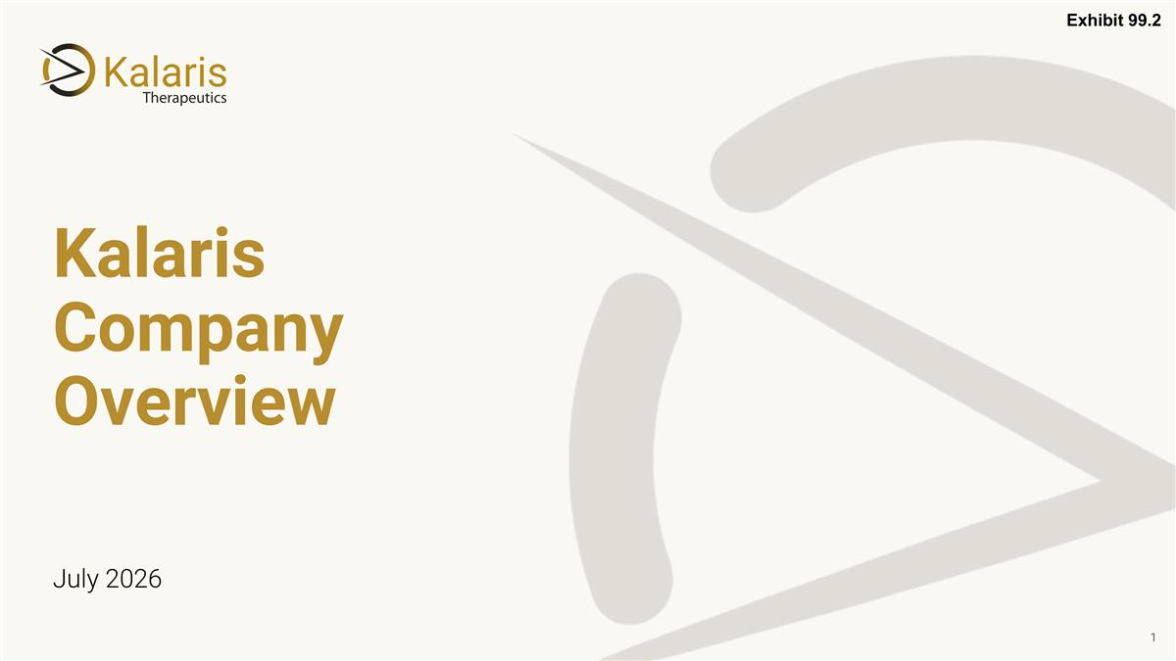
July 2026 Kalaris Company Overview Exhibit 99.2


Forward-Looking Statements & Disclaimer This presentation contains “forward-looking statements” within the meaning of the U.S. Private Securities Litigation Reform Act of 1995 and Section 21E of the Securities Exchange Act of 1934, as amended, that involve substantial risk and uncertainties. All statements, other than statements of historical fact, contained in this presentation, including statements regarding the strategy, future operations, prospects, plans and objectives of management of Kalaris, the therapeutic potential of TH103 for neovascular Age-related Macular Degeneration and other exudative and neovascular retinal diseases, the anticipated timeline for reporting data from the ongoing Phase 1b/2 clinical trial of TH103, plans to advance TH103 into Phase 3 clinical trials and to develop TH103 for additional indications, plans to improve the manufacturing process for TH103 and the sufficiency of Kalaris’ cash resources for the period anticipated, are forward-looking statements. The words “anticipate,” “believe,” “continue,” “could,” “estimate,” “expect,” “intend,” “may,” “might,” “plan,” “potential,” “predict,” “project,” “should,” “target,” “would” and similar expressions are intended to identify forward-looking statements, although not all forward-looking statements contain these identifying words. These statements are based on current expectations and beliefs of the management of Kalaris as well as assumptions made by, and information currently available to, the management of Kalaris and are subject to risks and uncertainties. There can be no assurance that future developments affecting Kalaris will be those that it has anticipated. Actual results or events could differ materially from the plans, intentions and expectations disclosed in these forward-looking statements as a result of various important factors, including: risks associated with the clinical development and regulatory approval of TH103, including potential delays in the completion of clinical trials; expectations regarding the therapeutic benefits, clinical potential and clinical development of TH103; the timing of and Kalaris’ ability to enroll patients in clinical trials; whether results from preclinical studies and initial data from early clinical trials will be predictive of the final results of the clinical trials or future trials; dependence on third parties for the development and manufacture of TH103; risks related to the inability of Kalaris to obtain sufficient additional capital to continue to advance its product candidate; uncertainties in obtaining successful clinical results for product candidates and unexpected costs that may result therefrom; risks related to the failure to realize any value from any product candidates being developed and anticipated to be developed in light of inherent risks and difficulties involved in successfully bringing product candidates to market; the ability to obtain, maintain, and protect intellectual property rights related to product candidates; changes in regulatory requirements and government incentives; Kalaris’ competitive position and expectations regarding developments and projections relating to its competitors and any competing therapies that are or become available; the risk of involvement in current and future litigation; and such other factors as are set forth in Kalaris’ public filings with the U.S. Securities and Exchange Commission, including, but not limited to, those described under the heading “Risk Factors”. Kalaris may not actually achieve the plans, intentions or expectations disclosed in its forward-looking statements, and you should not place undue reliance on its forward-looking statements. Actual results or events could differ materially from the plans, intentions and expectations disclosed in the forward-looking statements Kalaris makes. The forward-looking statements contained in this presentation are made as of the date of this presentation, and Kalaris does not assume any obligation to update any forward-looking statements, whether as a result of new information, future events or otherwise, except as required by applicable law. This presentation also contains estimates, projections and other statistical data made by independent parties and by Kalaris relating to market size and growth and other data about Kalaris’ industry and business. This data involves a number of assumptions and limitations, and you are cautioned not to give undue weight to such estimates. Kalaris has not independently verified the accuracy and completeness of the information obtained by third parties included in this presentation. In addition, projections, assumptions and estimates of Kalaris’ future performance and the future performance of the market in which Kalaris operates are necessarily subject to high degree of uncertainty and risk.

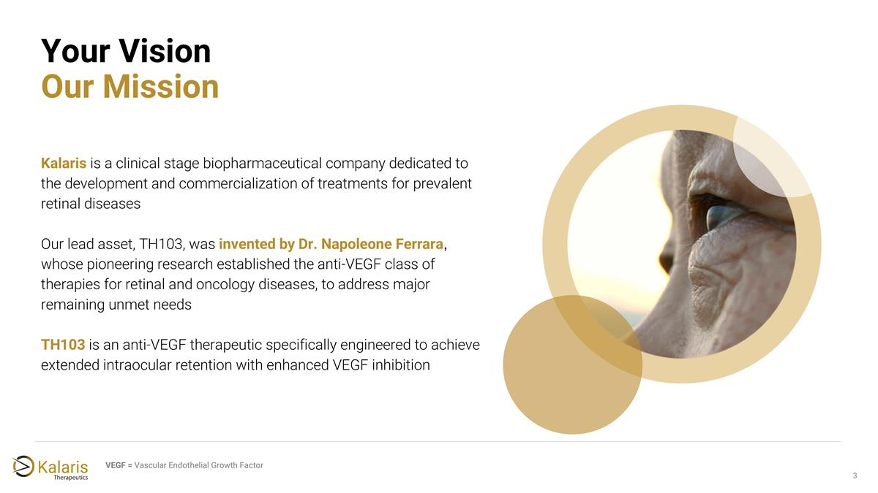
Your Vision Our Mission Kalaris is a clinical stage biopharmaceutical company dedicated to the development and commercialization of treatments for prevalent retinal diseases Our lead asset, TH103, was invented by Dr. Napoleone Ferrara, whose pioneering research established the anti-VEGF class of therapies for retinal and oncology diseases, to address major remaining unmet needs TH103 is an anti-VEGF therapeutic specifically engineered to achieve extended intraocular retention with enhanced VEGF inhibition VEGF = Vascular Endothelial Growth Factor

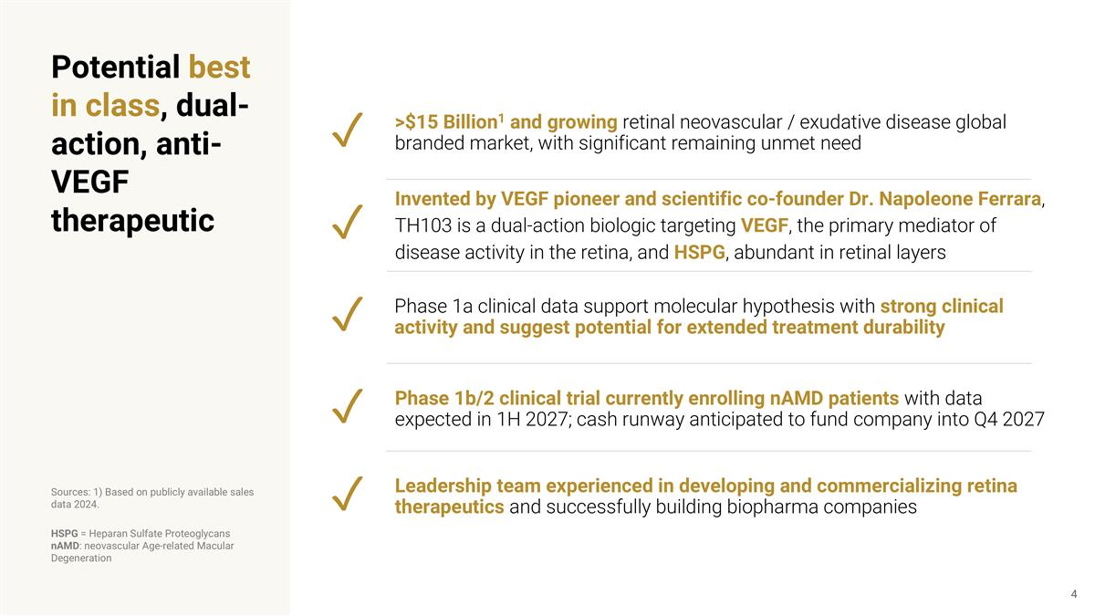
Invented by VEGF pioneer and scientific co-founder Dr. Napoleone Ferrara, TH103 is a dual-action biologic targeting VEGF, the primary mediator of disease activity in the retina, and HSPG, abundant in retinal layers Phase 1b/2 clinical trial currently enrolling nAMD patients with data expected in 1H 2027; cash runway anticipated to fund company into Q4 2027 ✓ >$15 Billion1 and growing retinal neovascular / exudative disease global branded market, with significant remaining unmet need ✓ ✓ ✓ Sources: 1) Based on publicly available sales data 2024. Phase 1a clinical data support molecular hypothesis with strong clinical activity and suggest potential for extended treatment durability Potential best in class, dual-action, anti-VEGF therapeutic Leadership team experienced in developing and commercializing retina therapeutics and successfully building biopharma companies ✓ HSPG = Heparan Sulfate Proteoglycans nAMD: neovascular Age-related Macular Degeneration

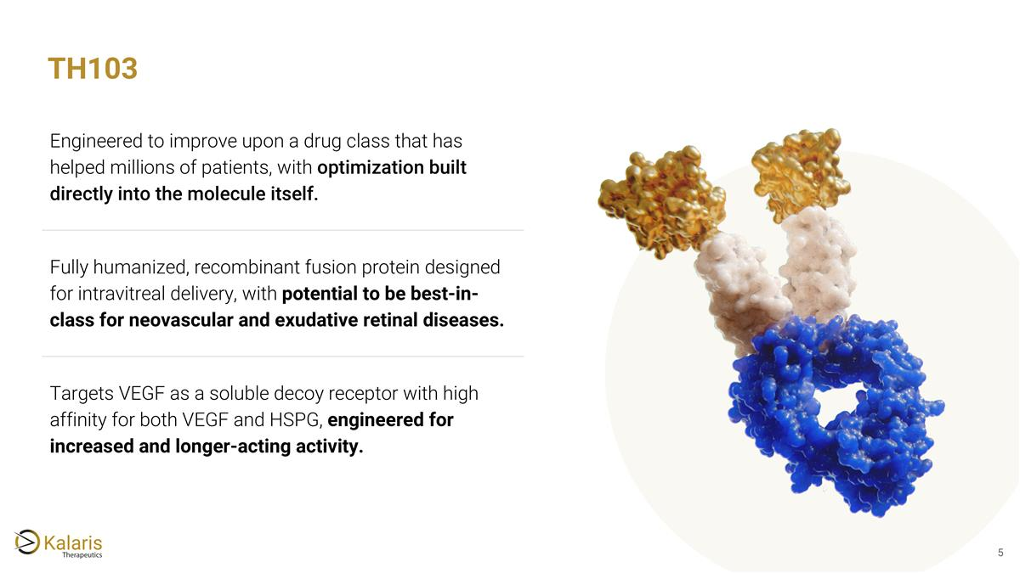
Engineered to improve upon a drug class that has helped millions of patients, with optimization built directly into the molecule itself. Fully humanized, recombinant fusion protein designed for intravitreal delivery, with potential to be best-in-class for neovascular and exudative retinal diseases. Targets VEGF as a soluble decoy receptor with high affinity for both VEGF and HSPG, engineered for increased and longer-acting activity. TH103


Anti-VEGF Therapeutics Background

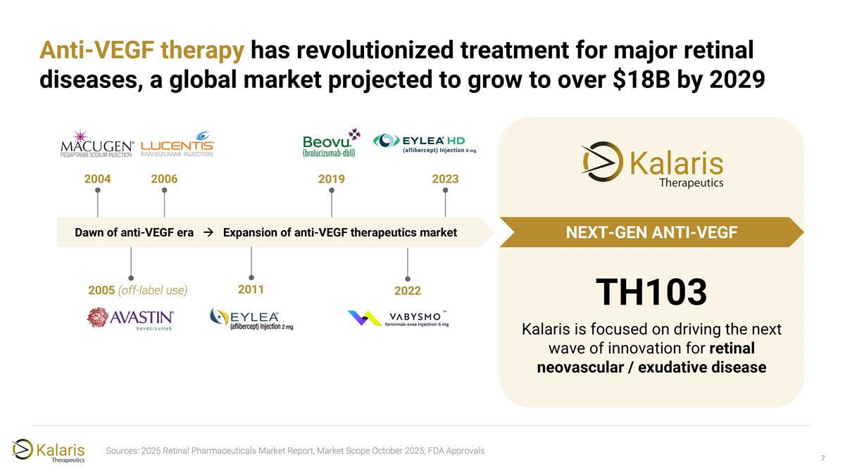
Anti-VEGF therapy has revolutionized treatment for major retinal diseases, a global market projected to grow to over $18B by 2029 Sources: 2025 Retinal Pharmaceuticals Market Report, Market Scope October 2025; FDA Approvals TH103 Kalaris is focused on driving the next wave of innovation for retinal neovascular / exudative disease Dawn of anti-VEGF era à Expansion of anti-VEGF therapeutics market NEXT-GEN ANTI-VEGF 2004 2006 2005 (off-label use) 2011 2019 2023 2022

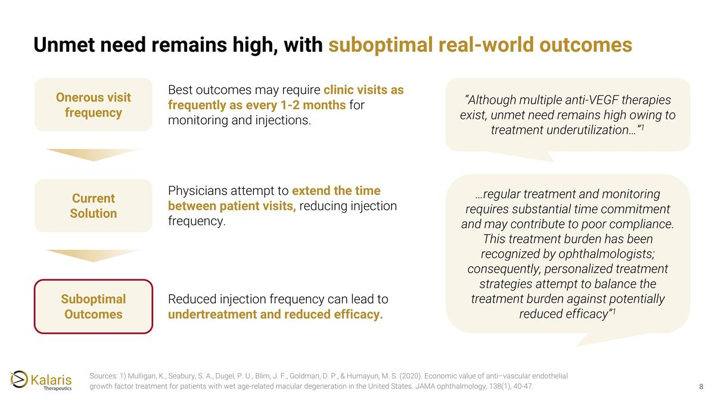
Unmet need remains high, with suboptimal real-world outcomes Sources: 1) Mulligan, K., Seabury, S. A., Dugel, P. U., Blim, J. F., Goldman, D. P., & Humayun, M. S. (2020). Economic value of anti–vascular endothelial growth factor treatment for patients with wet age-related macular degeneration in the United States. JAMA ophthalmology, 138(1), 40-47. Best outcomes may require clinic visits as frequently as every 1-2 months for monitoring and injections. Onerous visit frequency Physicians attempt to extend the time between patient visits, reducing injection frequency. Current Solution Reduced injection frequency can lead to undertreatment and reduced efficacy. Suboptimal Outcomes “Although multiple anti-VEGF therapies exist, unmet need remains high owing to treatment underutilization…”1 …regular treatment and monitoring requires substantial time commitment and may contribute to poor compliance. This treatment burden has been recognized by ophthalmologists; consequently, personalized treatment strategies attempt to balance the treatment burden against potentially reduced efficacy”1

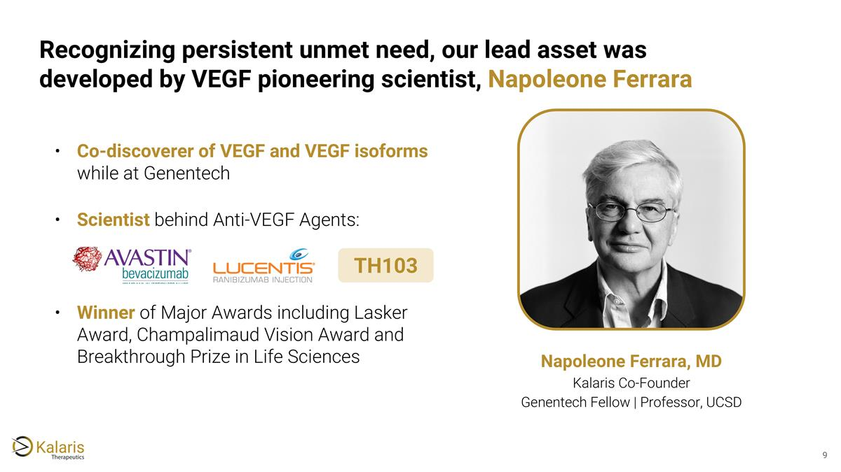
Recognizing persistent unmet need, our lead asset was developed by VEGF pioneering scientist, Napoleone Ferrara Co-discoverer of VEGF and VEGF isoforms while at Genentech Scientist behind Anti-VEGF Agents: Winner of Major Awards including Lasker Award, Champalimaud Vision Award and Breakthrough Prize in Life Sciences Napoleone Ferrara, MD Kalaris Co-Founder Genentech Fellow​ | Professor, UCSD​ TH103

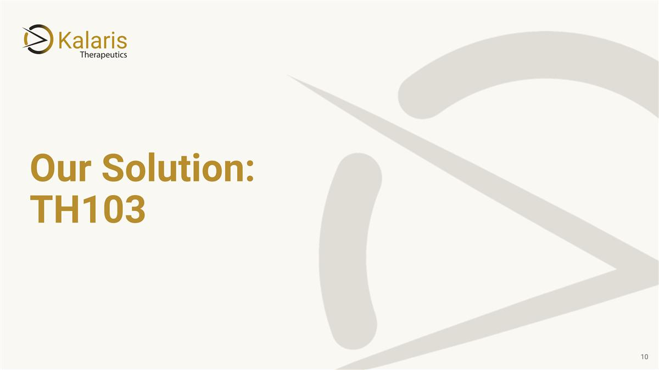
Our Solution: TH103

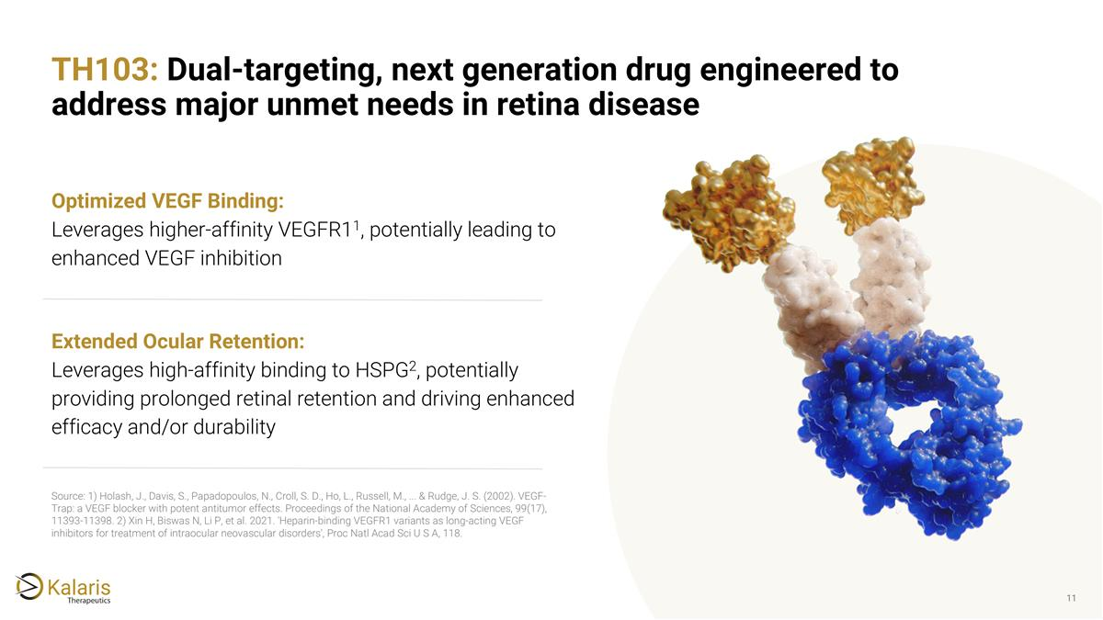
TH103: Dual-targeting, next generation drug engineered to address major unmet needs in retina disease Optimized VEGF Binding: Leverages higher-affinity VEGFR11, potentially leading to enhanced VEGF inhibition Extended Ocular Retention: Leverages high-affinity binding to HSPG2, potentially providing prolonged retinal retention and driving enhanced efficacy and/or durability Source: 1) Holash, J., Davis, S., Papadopoulos, N., Croll, S. D., Ho, L., Russell, M., ... & Rudge, J. S. (2002). VEGF-Trap: a VEGF blocker with potent antitumor effects. Proceedings of the National Academy of Sciences, 99(17), 11393-11398. 2) Xin H, Biswas N, Li P, et al. 2021. 'Heparin-binding VEGFR1 variants as long-acting VEGF inhibitors for treatment of intraocular neovascular disorders', Proc Natl Acad Sci U S A, 118.

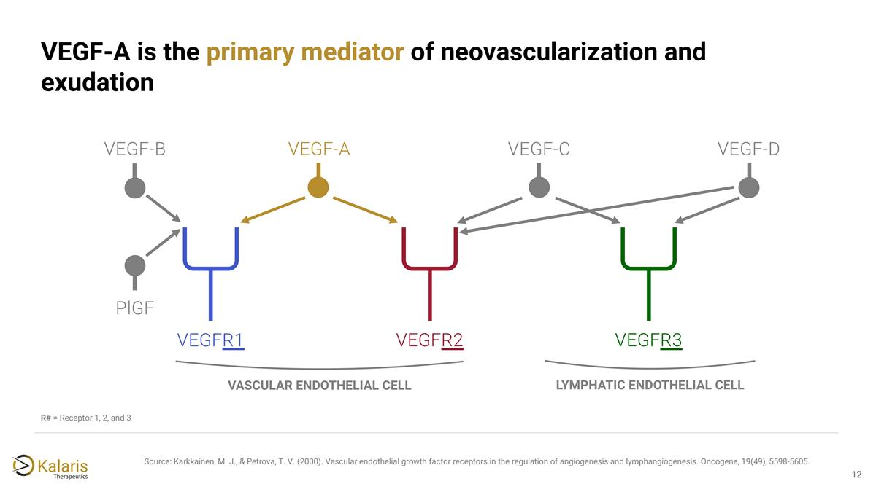
R# = Receptor 1, 2, and 3 Source: Karkkainen, M. J., & Petrova, T. V. (2000). Vascular endothelial growth factor receptors in the regulation of angiogenesis and lymphangiogenesis. Oncogene, 19(49), 5598-5605. VEGFR1 VEGFR2 VEGFR3 VEGF-B PlGF VEGF-A VEGF-D VEGF-C VASCULAR ENDOTHELIAL CELL LYMPHATIC ENDOTHELIAL CELL VEGF-A is the primary mediator of neovascularization and exudation

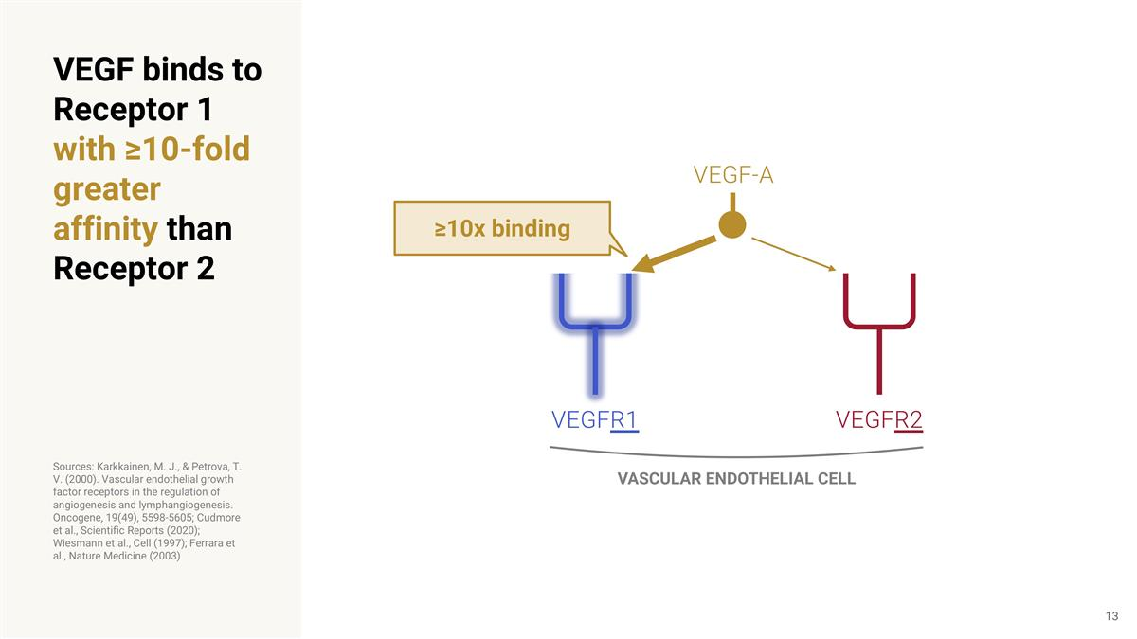
VEGF binds to Receptor 1 with ≥10-fold greater affinity than Receptor 2 Sources: Karkkainen, M. J., & Petrova, T. V. (2000). Vascular endothelial growth factor receptors in the regulation of angiogenesis and lymphangiogenesis. Oncogene, 19(49), 5598-5605; Cudmore et al., Scientific Reports (2020); Wiesmann et al., Cell (1997); Ferrara et al., Nature Medicine (2003) VEGFR1 VEGFR2 VASCULAR ENDOTHELIAL CELL ≥10x binding VEGF-A

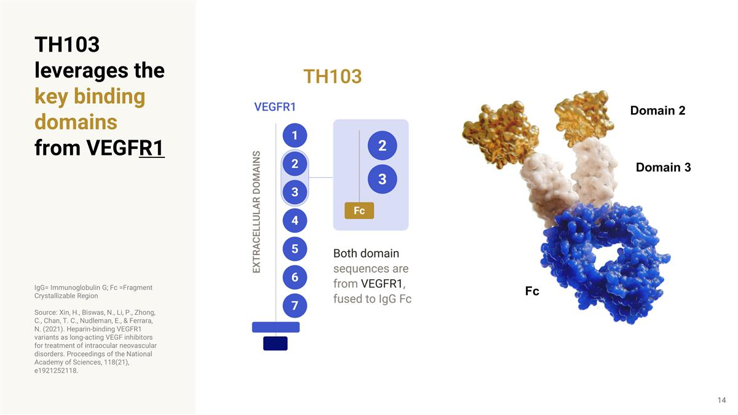
TH103 leverages the key binding domains from VEGFR1 IgG= Immunoglobulin G; Fc =Fragment Crystallizable Region Source: Xin, H., Biswas, N., Li, P., Zhong, C., Chan, T. C., Nudleman, E., & Ferrara, N. (2021). Heparin-binding VEGFR1 variants as long-acting VEGF inhibitors for treatment of intraocular neovascular disorders. Proceedings of the National Academy of Sciences, 118(21), e1921252118. Domain 2 Domain 3 Fc

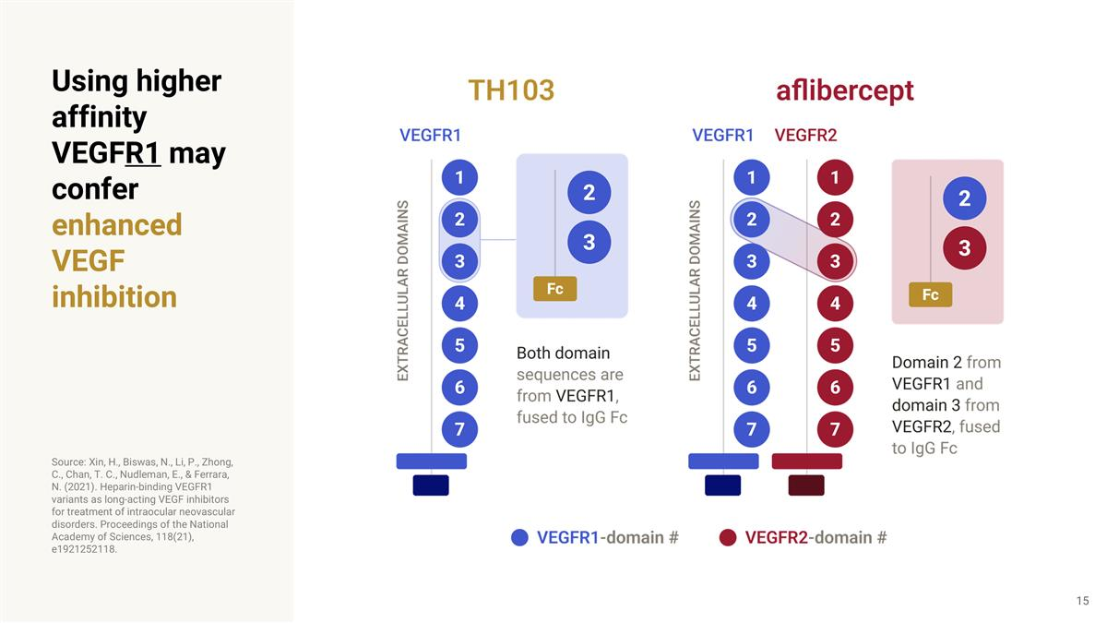
Using higher affinity VEGFR1 may confer enhanced VEGF inhibition Source: Xin, H., Biswas, N., Li, P., Zhong, C., Chan, T. C., Nudleman, E., & Ferrara, N. (2021). Heparin-binding VEGFR1 variants as long-acting VEGF inhibitors for treatment of intraocular neovascular disorders. Proceedings of the National Academy of Sciences, 118(21), e1921252118.

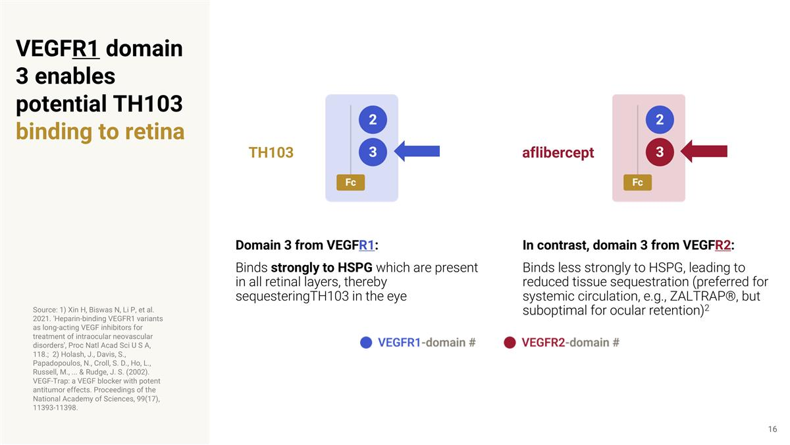
VEGFR1 domain 3 enables potential TH103 binding to retina Source: 1) Xin H, Biswas N, Li P, et al. 2021. 'Heparin-binding VEGFR1 variants as long-acting VEGF inhibitors for treatment of intraocular neovascular disorders', Proc Natl Acad Sci U S A, 118.; 2) Holash, J., Davis, S., Papadopoulos, N., Croll, S. D., Ho, L., Russell, M., ... & Rudge, J. S. (2002). VEGF-Trap: a VEGF blocker with potent antitumor effects. Proceedings of the National Academy of Sciences, 99(17), 11393-11398. In contrast, domain 3 from VEGFR2: Binds less strongly to HSPG, leading to reduced tissue sequestration (preferred for systemic circulation, e.g., ZALTRAP®, but suboptimal for ocular retention)2 aflibercept Domain 3 from VEGFR1: Binds strongly to HSPG which are present in all retinal layers, thereby sequesteringTH103 in the eye TH103

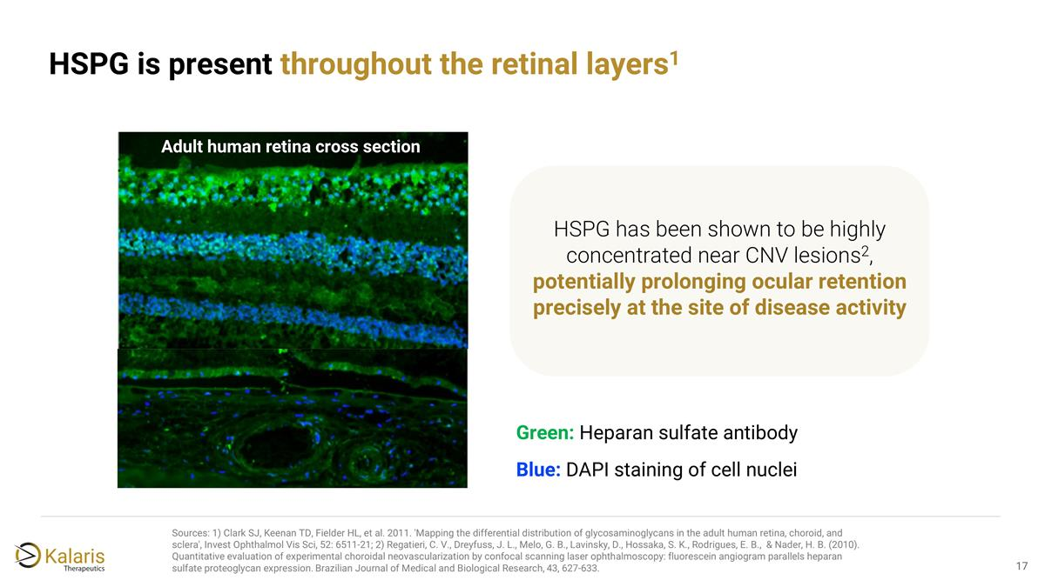
Sources: 1) Clark SJ, Keenan TD, Fielder HL, et al. 2011. 'Mapping the differential distribution of glycosaminoglycans in the adult human retina, choroid, and sclera', Invest Ophthalmol Vis Sci, 52: 6511-21; 2) Regatieri, C. V., Dreyfuss, J. L., Melo, G. B., Lavinsky, D., Hossaka, S. K., Rodrigues, E. B., & Nader, H. B. (2010). Quantitative evaluation of experimental choroidal neovascularization by confocal scanning laser ophthalmoscopy: fluorescein angiogram parallels heparan sulfate proteoglycan expression. Brazilian Journal of Medical and Biological Research, 43, 627-633. Adult human retina cross section HSPG has been shown to be highly concentrated near CNV lesions2, potentially prolonging ocular retention precisely at the site of disease activity Blue: DAPI staining of cell nuclei Green: Heparan sulfate antibody HSPG is present throughout the retinal layers1

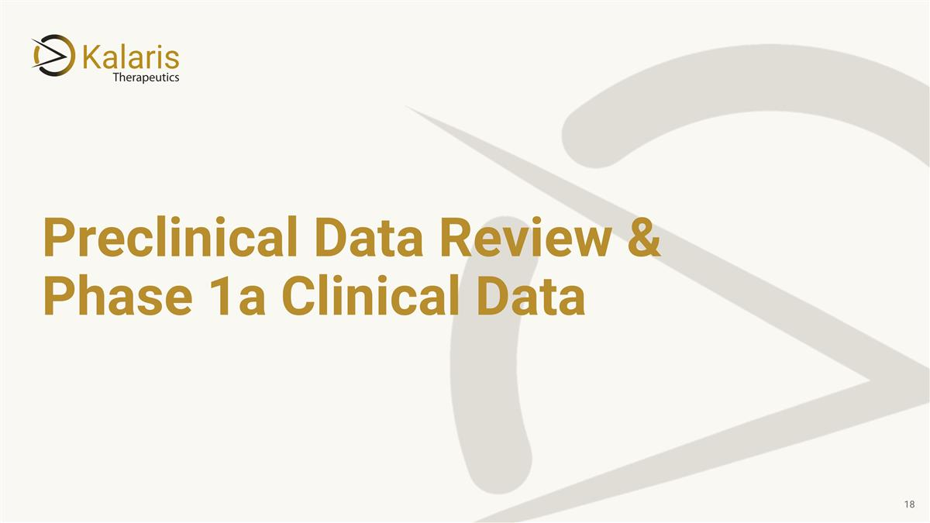
Preclinical Data Review & Phase 1a Clinical Data

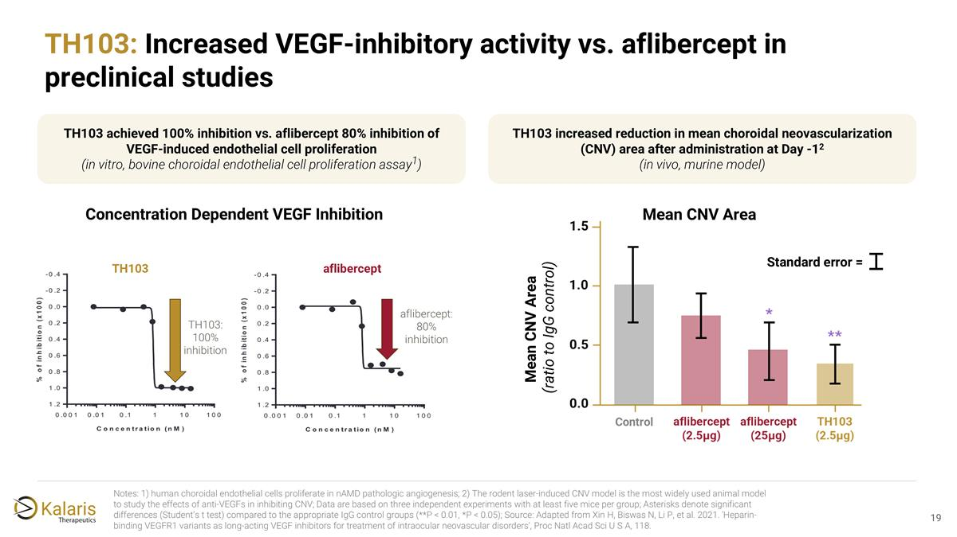
Notes: 1) human choroidal endothelial cells proliferate in nAMD pathologic angiogenesis; 2) The rodent laser-induced CNV model is the most widely used animal model to study the effects of anti-VEGFs in inhibiting CNV; Data are based on three independent experiments with at least five mice per group; Asterisks denote significant differences (Student’s t test) compared to the appropriate IgG control groups (**P < 0.01, *P < 0.05); Source: Adapted from Xin H, Biswas N, Li P, et al. 2021. 'Heparin-binding VEGFR1 variants as long-acting VEGF inhibitors for treatment of intraocular neovascular disorders', Proc Natl Acad Sci U S A, 118. TH103: Increased VEGF-inhibitory activity vs. aflibercept in preclinical studies TH103 achieved 100% inhibition vs. aflibercept 80% inhibition of VEGF-induced endothelial cell proliferation (in vitro, bovine choroidal endothelial cell proliferation assay1) aflibercept TH103 Concentration Dependent VEGF Inhibition Mean CNV Area Mean CNV Area (ratio to IgG control) Standard error = TH103 increased reduction in mean choroidal neovascularization (CNV) area after administration at Day -12 (in vivo, murine model)

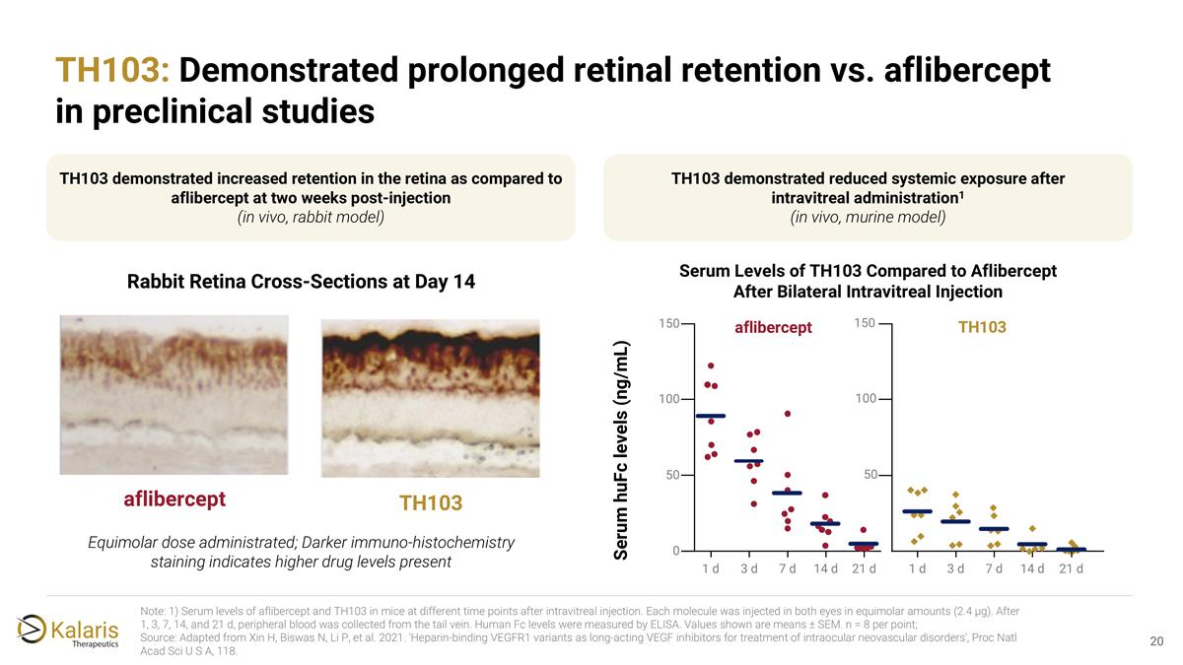
Note: 1) Serum levels of aflibercept and TH103 in mice at different time points after intravitreal injection. Each molecule was injected in both eyes in equimolar amounts (2.4 μg). After 1, 3, 7, 14, and 21 d, peripheral blood was collected from the tail vein. Human Fc levels were measured by ELISA. Values shown are means ± SEM. n = 8 per point; Source: Adapted from Xin H, Biswas N, Li P, et al. 2021. 'Heparin-binding VEGFR1 variants as long-acting VEGF inhibitors for treatment of intraocular neovascular disorders', Proc Natl Acad Sci U S A, 118. TH103: Demonstrated prolonged retinal retention vs. aflibercept in preclinical studies Serum Levels of TH103 Compared to Aflibercept After Bilateral Intravitreal Injection aflibercept TH103 Rabbit Retina Cross-Sections at Day 14 Equimolar dose administrated; Darker immuno-histochemistry staining indicates higher drug levels present TH103 demonstrated increased retention in the retina as compared to aflibercept at two weeks post-injection (in vivo, rabbit model) TH103 demonstrated reduced systemic exposure after intravitreal administration1 (in vivo, murine model) Serum huFc levels (ng/mL) 0 50 100 150 1 d 3 d 7 d 14 d 21 d 3 d 7 d 14 d 21 d 1 d aflibercept TH103 50 100 150

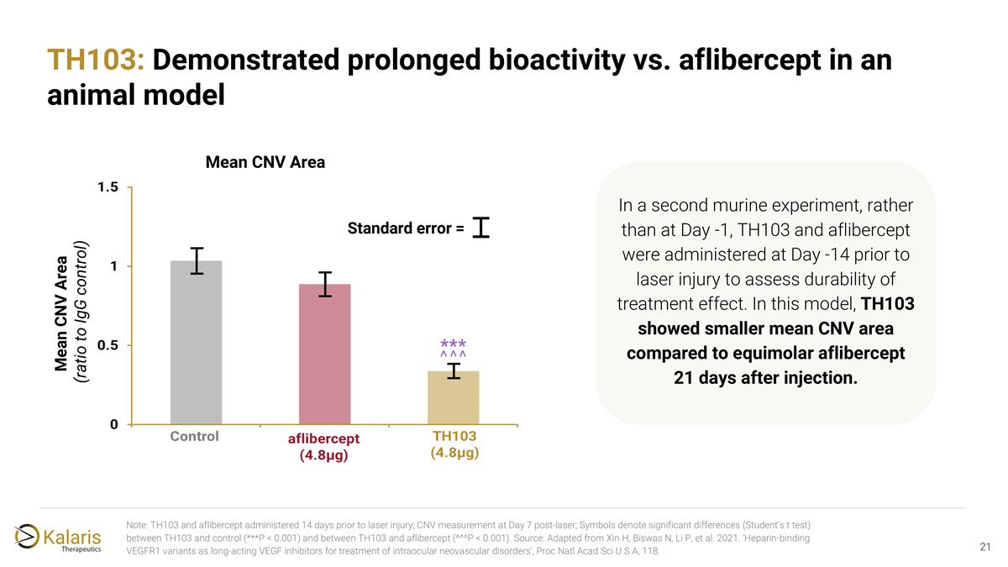
Note: TH103 and aflibercept administered 14 days prior to laser injury; CNV measurement at Day 7 post-laser; Symbols denote significant differences (Student’s t test) between TH103 and control (***P < 0.001) and between TH103 and aflibercept (^^^P < 0.001). Source: Adapted from Xin H, Biswas N, Li P, et al. 2021. 'Heparin-binding VEGFR1 variants as long-acting VEGF inhibitors for treatment of intraocular neovascular disorders', Proc Natl Acad Sci U S A, 118. TH103: Demonstrated prolonged bioactivity vs. aflibercept in an animal model Mean CNV Area Mean CNV Area (ratio to IgG control) Standard error = In a second murine experiment, rather than at Day -1, TH103 and aflibercept were administered at Day -14 prior to laser injury to assess durability of treatment effect. In this model, ​TH103 showed smaller mean CNV area compared to equimolar aflibercept​ 21 days after injection.

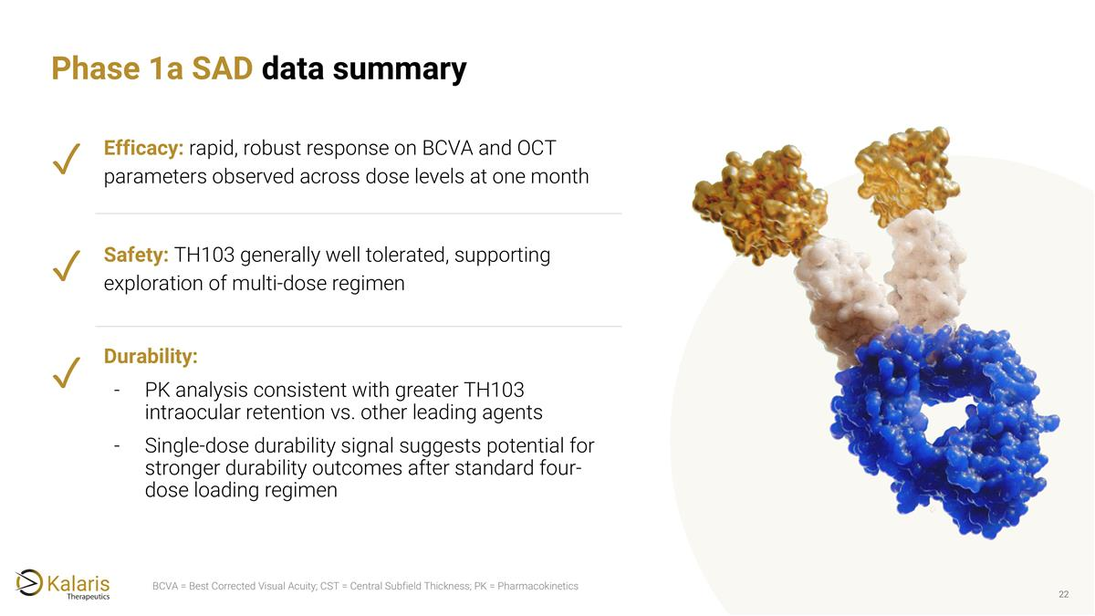
Phase 1a SAD data summary BCVA = Best Corrected Visual Acuity; CST = Central Subfield Thickness; PK = Pharmacokinetics Durability: PK analysis consistent with greater TH103 intraocular retention vs. other leading agents Single-dose durability signal suggests potential for stronger durability outcomes after standard four-dose loading regimen ✓ ✓ ✓ Efficacy: rapid, robust response on BCVA and OCT parameters observed across dose levels at one month Safety: TH103 generally well tolerated, supporting exploration of multi-dose regimen

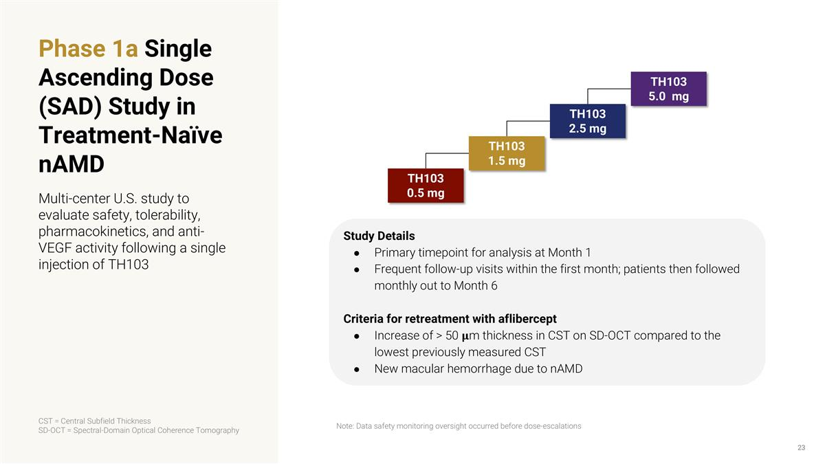
Phase 1a Single Ascending Dose (SAD) Study in Treatment-Naïve nAMD Multi-center U.S. study to evaluate safety, tolerability, pharmacokinetics, and anti-VEGF activity following a single injection of TH103 Study Details Primary timepoint for analysis at Month 1 Frequent follow-up visits within the first month; patients then followed monthly out to Month 6 Criteria for retreatment with aflibercept Increase of > 50 𝛍m thickness in CST on SD-OCT compared to the lowest previously measured CST New macular hemorrhage due to nAMD CST = Central Subfield Thickness SD-OCT = Spectral-Domain Optical Coherence Tomography Note: Data safety monitoring oversight occurred before dose-escalations TH103 0.5 mg TH103 1.5 mg TH103 2.5 mg TH103 5.0 mg

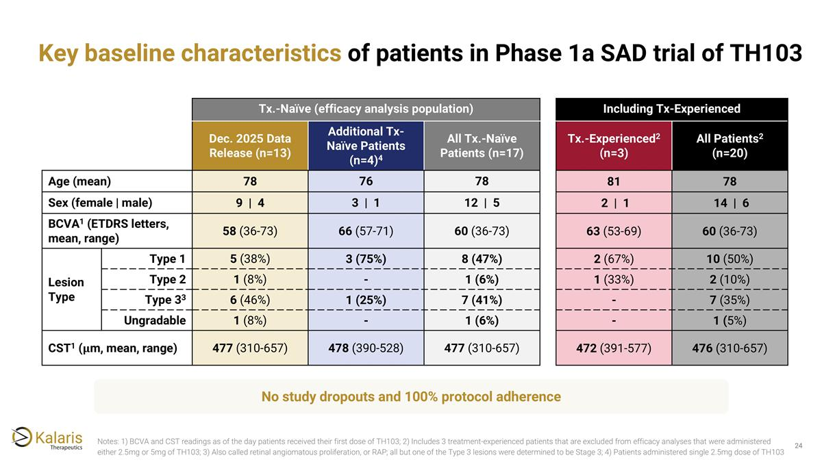
Key baseline characteristics of patients in Phase 1a SAD trial of TH103 No study dropouts and 100% protocol adherence Tx.-Naïve (efficacy analysis population) Including Tx-Experienced Dec. 2025 Data Release (n=13) Additional Tx-Naïve Patients (n=4)4 All Tx.-Naïve Patients (n=17) Tx.-Experienced2 (n=3) All Patients2 (n=20) Age (mean) 78 76 78 81 78 Sex (female | male) 9 | 4 3 | 1 12 | 5 2 | 1 14 | 6 BCVA1 (ETDRS letters, mean, range) 58 (36-73) 66 (57-71) 60 (36-73) 63 (53-69) 60 (36-73) Lesion Type Type 1 5 (38%) 3 (75%) 8 (47%) 2 (67%) 10 (50%) Type 2 1 (8%) - 1 (6%) 1 (33%) 2 (10%) Type 33 6 (46%) 1 (25%) 7 (41%) - 7 (35%) Ungradable 1 (8%) - 1 (6%) - 1 (5%) CST1 (𝛍m, mean, range) 477 (310-657) 478 (390-528) 477 (310-657) 472 (391-577) 476 (310-657) Notes: 1) BCVA and CST readings as of the day patients received their first dose of TH103; 2) Includes 3 treatment-experienced patients that are excluded from efficacy analyses that were administered either 2.5mg or 5mg of TH103; 3) Also called retinal angiomatous proliferation, or RAP; all but one of the Type 3 lesions were determined to be Stage 3; 4) Patients administered single 2.5mg dose of TH103

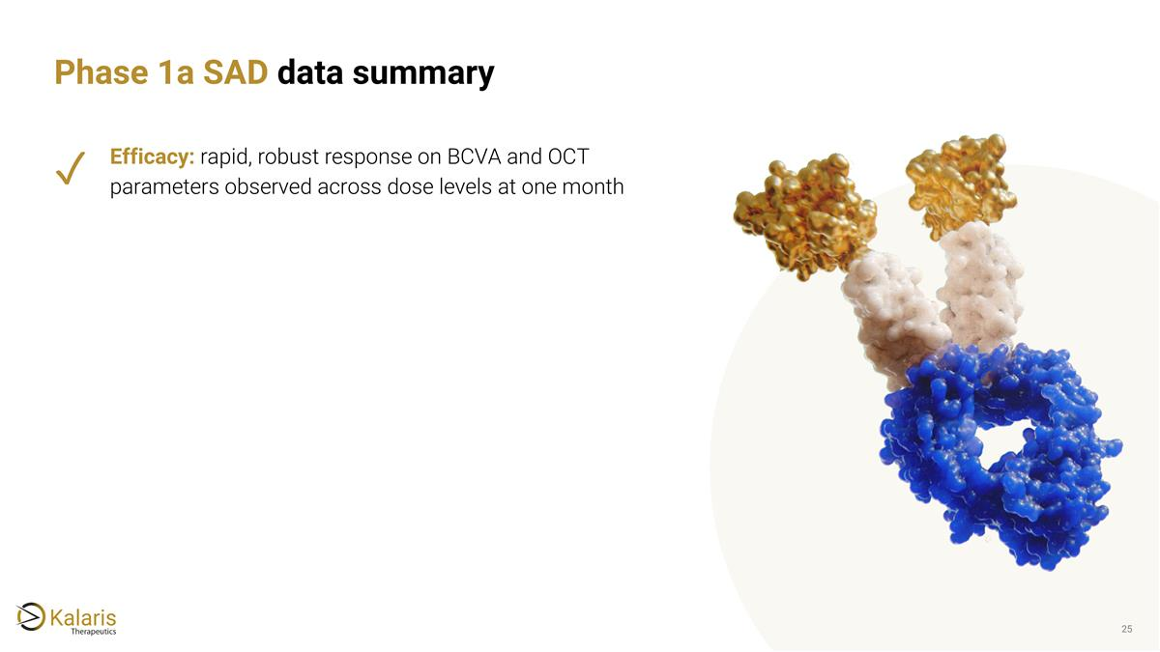
Phase 1a SAD data summary ✓ Efficacy: rapid, robust response on BCVA and OCT parameters observed across dose levels at one month

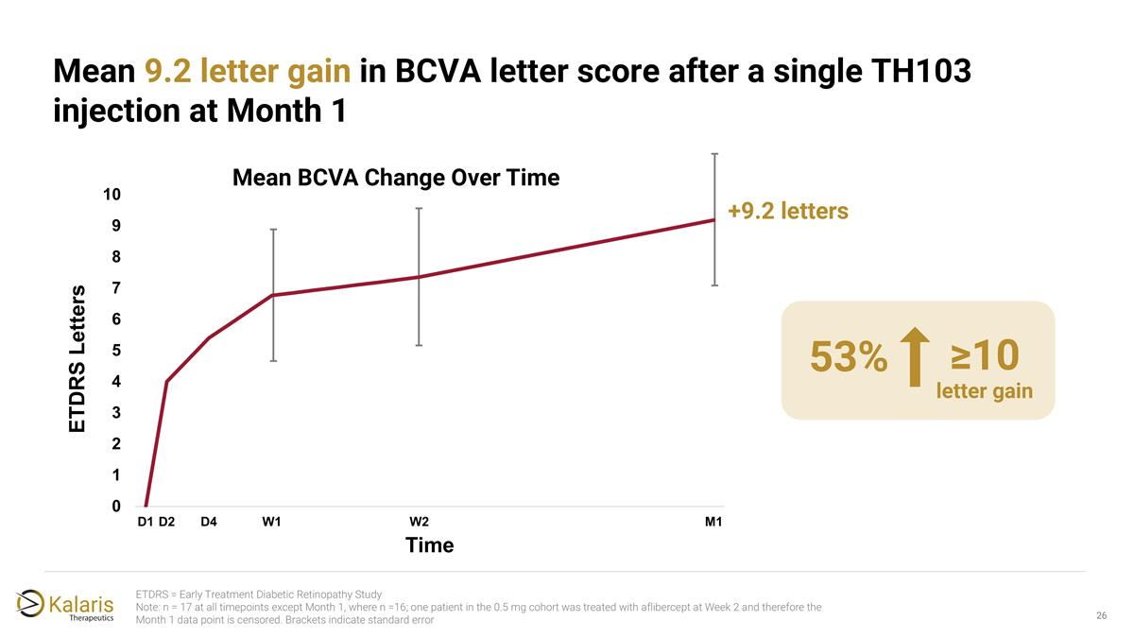
ETDRS = Early Treatment Diabetic Retinopathy Study Note: n = 17 at all timepoints except Month 1, where n =16; one patient in the 0.5 mg cohort was treated with aflibercept at Week 2 and therefore the Month 1 data point is censored. Brackets indicate standard error Mean 9.2 letter gain in BCVA letter score after a single TH103 injection at Month 1 +9.2 letters 53% letter gain ≥10

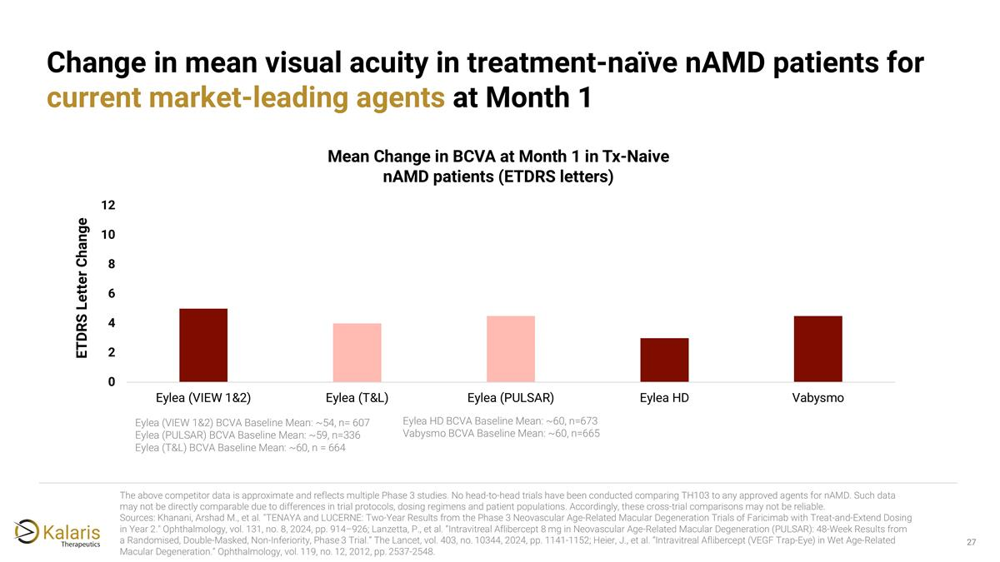
Eylea (VIEW 1&2) BCVA Baseline Mean: ~54, n= 607 Eylea (PULSAR) BCVA Baseline Mean: ~59, n=336 Eylea (T&L) BCVA Baseline Mean: ~60, n = 664 Eylea HD BCVA Baseline Mean: ~60, n=673 Vabysmo BCVA Baseline Mean: ~60, n=665 Change in mean visual acuity in treatment-naïve nAMD patients for current market-leading agents at Month 1 The above competitor data is approximate and reflects multiple Phase 3 studies. No head-to-head trials have been conducted comparing TH103 to any approved agents for nAMD. Such data may not be directly comparable due to differences in trial protocols, dosing regimens and patient populations. Accordingly, these cross-trial comparisons may not be reliable. Sources: Khanani, Arshad M., et al. "TENAYA and LUCERNE: Two-Year Results from the Phase 3 Neovascular Age-Related Macular Degeneration Trials of Faricimab with Treat-and-Extend Dosing in Year 2." Ophthalmology, vol. 131, no. 8, 2024, pp. 914–926; Lanzetta, P., et al. “Intravitreal Aflibercept 8 mg in Neovascular Age-Related Macular Degeneration (PULSAR): 48-Week Results from a Randomised, Double-Masked, Non-Inferiority, Phase 3 Trial.” The Lancet, vol. 403, no. 10344, 2024, pp. 1141-1152; Heier, J., et al. “Intravitreal Aflibercept (VEGF Trap-Eye) in Wet Age-Related Macular Degeneration.” Ophthalmology, vol. 119, no. 12, 2012, pp. 2537-2548. ETDRS Letter Change

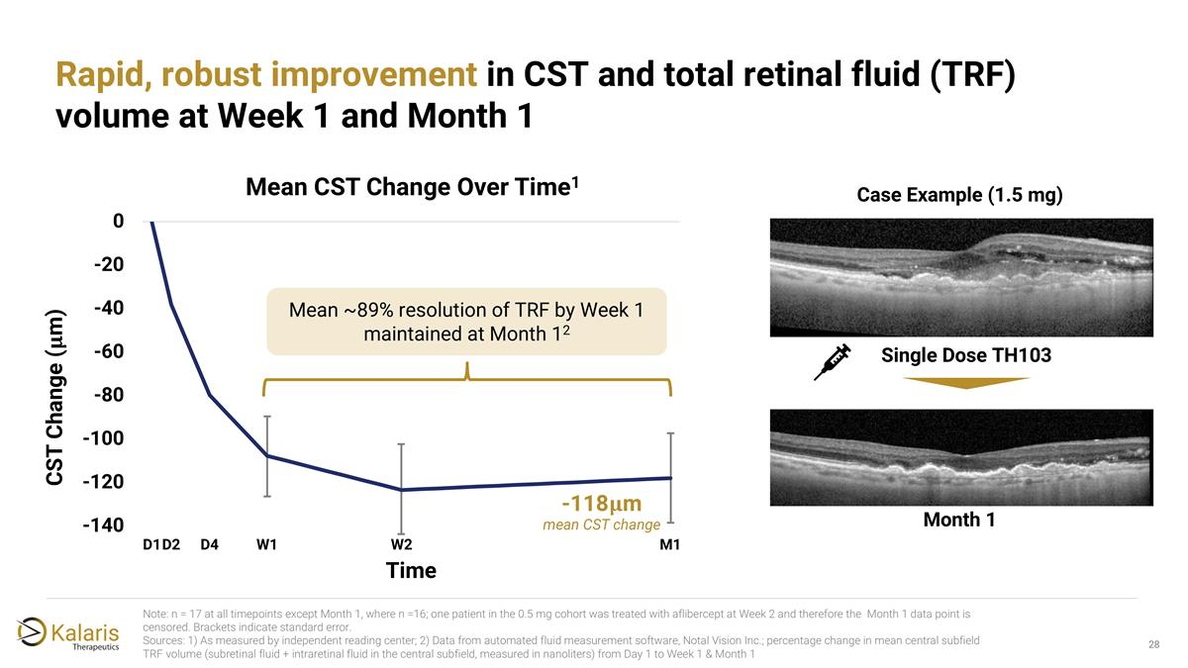
Rapid, robust improvement in CST and total retinal fluid (TRF) volume at Week 1 and Month 1 Case Example (1.5 mg) Mean ~89% resolution of TRF by Week 1 maintained at Month 12 Month 1 Note: n = 17 at all timepoints except Month 1, where n =16; one patient in the 0.5 mg cohort was treated with aflibercept at Week 2 and therefore the Month 1 data point is censored. Brackets indicate standard error. Sources: 1) As measured by independent reading center; 2) Data from automated fluid measurement software, Notal Vision Inc.; percentage change in mean central subfield TRF volume (subretinal fluid + intraretinal fluid in the central subfield, measured in nanoliters) from Day 1 to Week 1 & Month 1 Single Dose TH103 -118𝛍m mean CST change

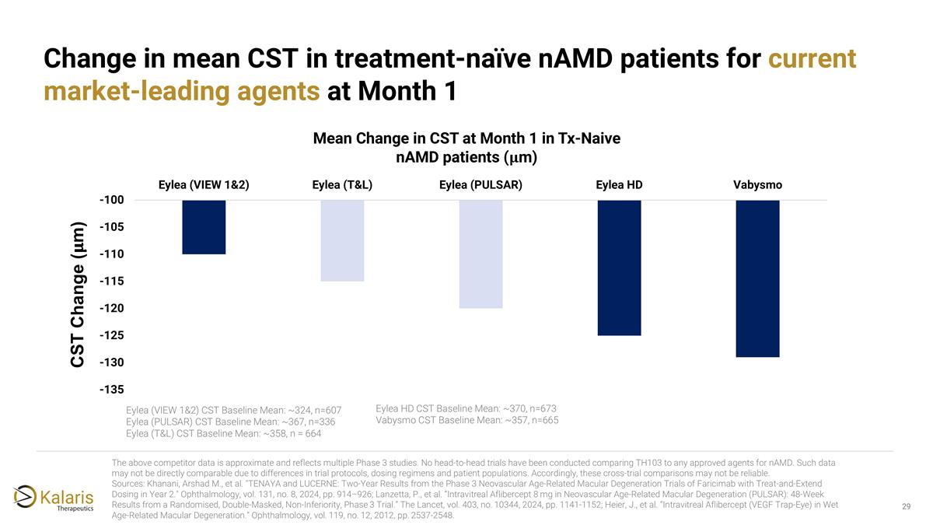
Eylea (VIEW 1&2) CST Baseline Mean: ~324, n=607 Eylea (PULSAR) CST Baseline Mean: ~367, n=336 Eylea (T&L) CST Baseline Mean: ~358, n = 664 Eylea HD CST Baseline Mean: ~370, n=673 Vabysmo CST Baseline Mean: ~357, n=665 Change in mean CST in treatment-naïve nAMD patients for current market-leading agents at Month 1 The above competitor data is approximate and reflects multiple Phase 3 studies. No head-to-head trials have been conducted comparing TH103 to any approved agents for nAMD. Such data may not be directly comparable due to differences in trial protocols, dosing regimens and patient populations. Accordingly, these cross-trial comparisons may not be reliable. Sources: Khanani, Arshad M., et al. "TENAYA and LUCERNE: Two-Year Results from the Phase 3 Neovascular Age-Related Macular Degeneration Trials of Faricimab with Treat-and-Extend Dosing in Year 2." Ophthalmology, vol. 131, no. 8, 2024, pp. 914–926; Lanzetta, P., et al. “Intravitreal Aflibercept 8 mg in Neovascular Age-Related Macular Degeneration (PULSAR): 48-Week Results from a Randomised, Double-Masked, Non-Inferiority, Phase 3 Trial.” The Lancet, vol. 403, no. 10344, 2024, pp. 1141-1152; Heier, J., et al. “Intravitreal Aflibercept (VEGF Trap-Eye) in Wet Age-Related Macular Degeneration.” Ophthalmology, vol. 119, no. 12, 2012, pp. 2537-2548. CST Change (𝛍m)

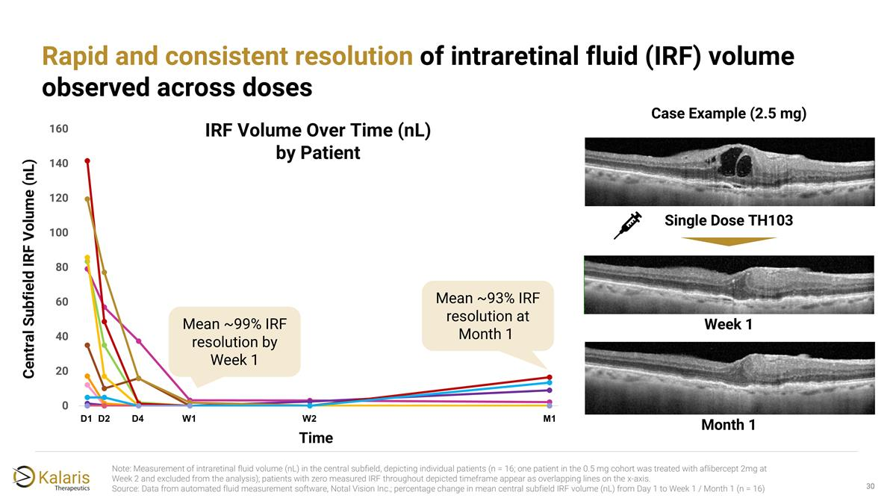
Note: Measurement of intraretinal fluid volume (nL) in the central subfield, depicting individual patients (n = 16; one patient in the 0.5 mg cohort was treated with aflibercept 2mg at Week 2 and excluded from the analysis); patients with zero measured IRF throughout depicted timeframe appear as overlapping lines on the x-axis. Source: Data from automated fluid measurement software, Notal Vision Inc.; percentage change in mean central subfield IRF volume (nL) from Day 1 to Week 1 / Month 1 (n = 16) Rapid and consistent resolution of intraretinal fluid (IRF) volume observed across doses Case Example (2.5 mg) Single Dose TH103 Month 1 Week 1 IRF Volume Over Time (nL) by Patient Central Subfield IRF Volume (nL) Time 14 D2 D1 D4 W1 W2 M1 Mean ~99% IRF resolution by Week 1 Mean ~93% IRF resolution at Month 1

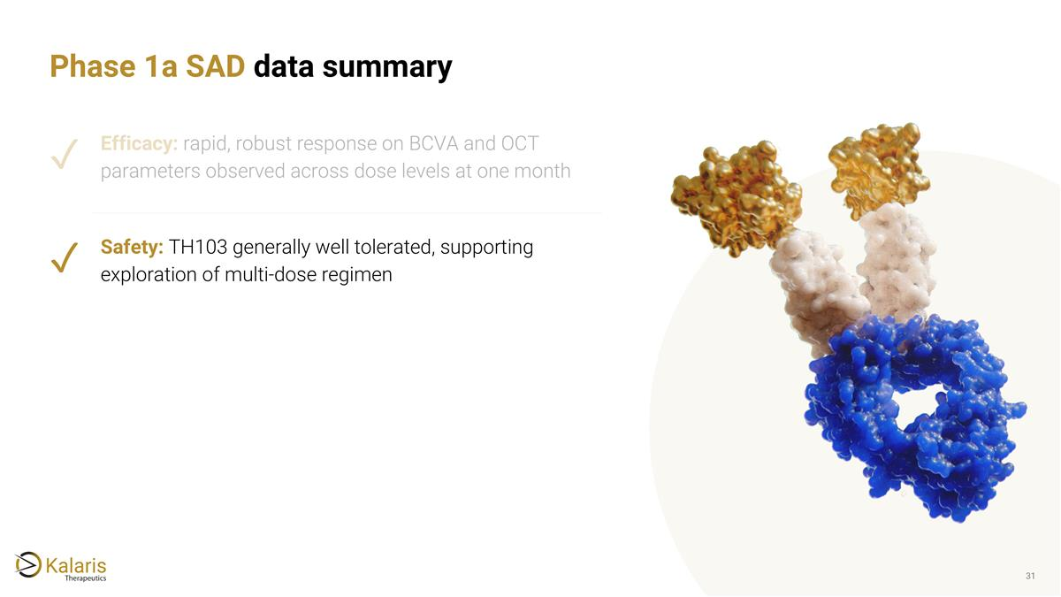
Phase 1a SAD data summary Efficacy: rapid, robust response on BCVA and OCT parameters observed across dose levels at one month Safety: TH103 generally well tolerated, supporting exploration of multi-dose regimen ✓ ✓

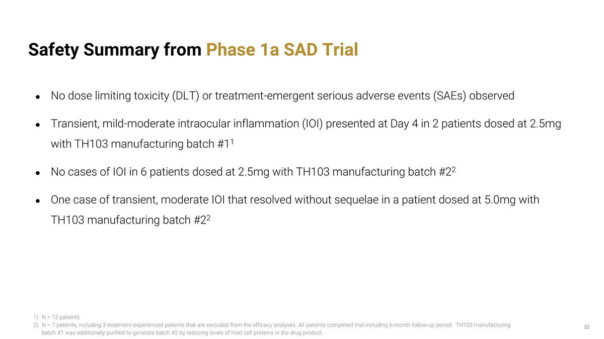
Safety Summary from Phase 1a SAD Trial No dose limiting toxicity (DLT) or treatment-emergent serious adverse events (SAEs) observed Transient, mild-moderate intraocular inflammation (IOI) presented at Day 4 in 2 patients dosed at 2.5mg with TH103 manufacturing batch #11 No cases of IOI in 6 patients dosed at 2.5mg with TH103 manufacturing batch #22 One case of transient, moderate IOI that resolved without sequelae in a patient dosed at 5.0mg with TH103 manufacturing batch #22 N = 13 patients N = 7 patients, including 3 treatment-experienced patients that are excluded from the efficacy analyses. All patients completed trial including 6-month follow-up period. TH103 manufacturing batch #1 was additionally purified to generate batch #2 by reducing levels of host cell proteins in the drug product.

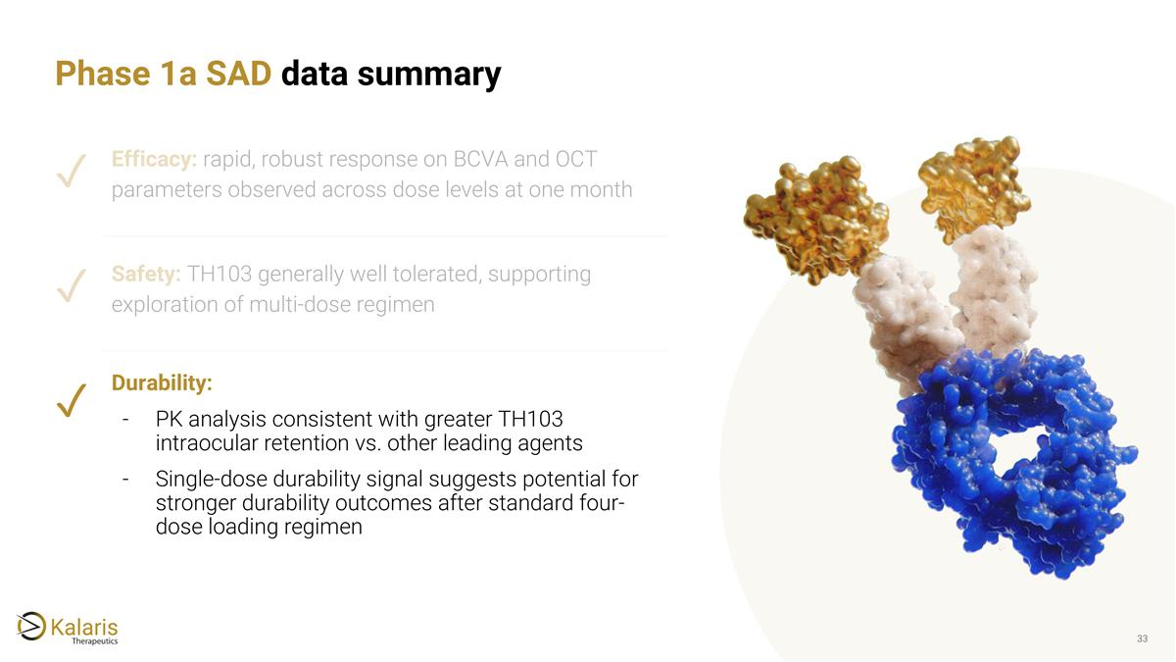
Phase 1a SAD data summary Efficacy: rapid, robust response on BCVA and OCT parameters observed across dose levels at one month Safety: TH103 generally well tolerated, supporting exploration of multi-dose regimen Durability: PK analysis consistent with greater TH103 intraocular retention vs. other leading agents Single-dose durability signal suggests potential for stronger durability outcomes after standard four-dose loading regimen ✓ ✓ ✓

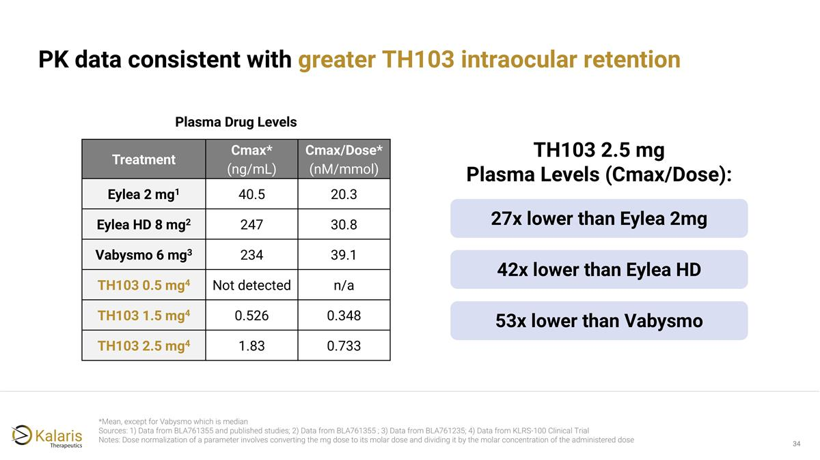
PK data consistent with greater TH103 intraocular retention *Mean, except for Vabysmo which is median Sources: 1) Data from BLA761355 and published studies; 2) Data from BLA761355 ; 3) Data from BLA761235; 4) Data from KLRS-100 Clinical Trial Notes: Dose normalization of a parameter involves converting the mg dose to its molar dose and dividing it by the molar concentration of the administered dose 27x lower than Eylea 2mg Treatment Cmax* (ng/mL) Cmax/Dose* (nM/mmol) Eylea 2 mg1 40.5 20.3 Eylea HD 8 mg2 247 30.8 Vabysmo 6 mg3 234 39.1 TH103 0.5 mg4 Not detected n/a TH103 1.5 mg4 0.526 0.348 TH103 2.5 mg4 1.83 0.733 TH103 2.5 mg Plasma Levels (Cmax/Dose): Plasma Drug Levels 42x lower than Eylea HD 53x lower than Vabysmo

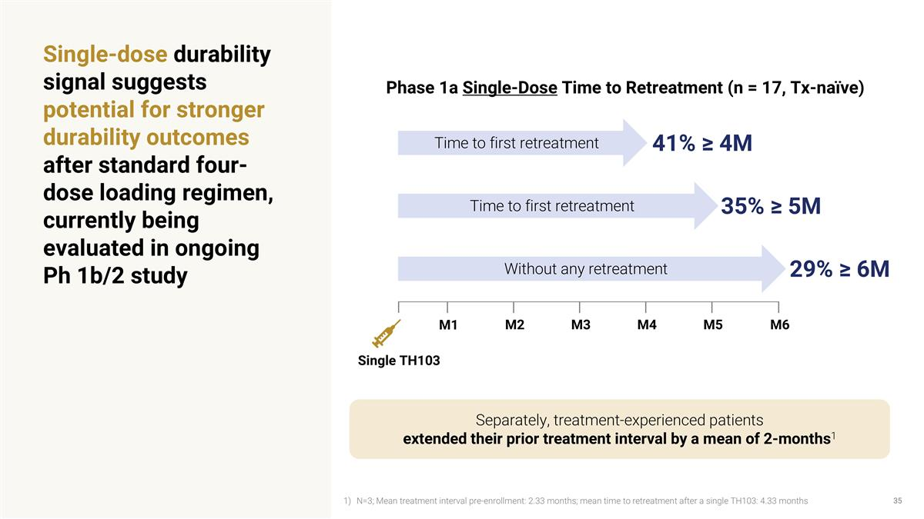
Single-dose durability signal suggests potential for stronger durability outcomes after standard four-dose loading regimen, currently being evaluated in ongoing Ph 1b/2 study M2 M3 M5 M6 M4 M1 Single TH103 Phase 1a Single-Dose Time to Retreatment (n = 17, Tx-naïve) 41% ≥ 4M Time to first retreatment Without any retreatment 29% ≥ 6M 35% ≥ 5M Time to first retreatment Separately, treatment-experienced patients extended their prior treatment interval by a mean of 2-months1 N=3; Mean treatment interval pre-enrollment: 2.33 months; mean time to retreatment after a single TH103: 4.33 months

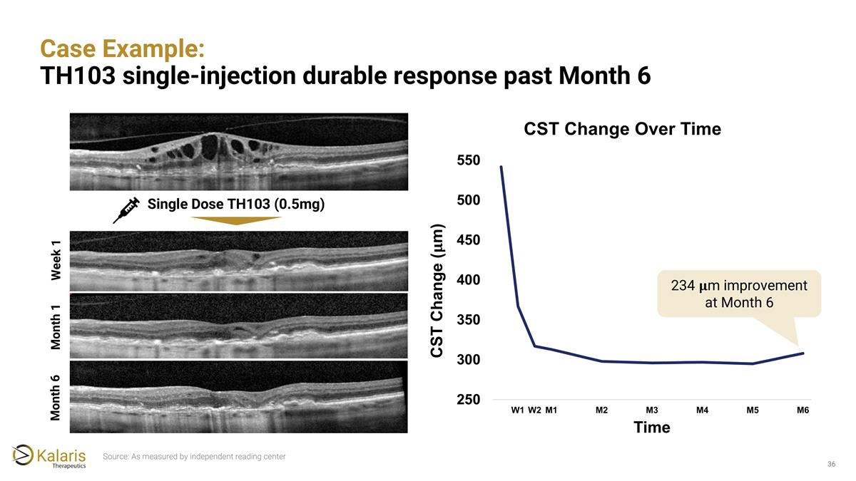
Case Example: TH103 single-injection durable response past Month 6 Single Dose TH103 (0.5mg) 234 𝛍m improvement at Month 6 Week 1 Month 1 Month 6 Source: As measured by independent reading center

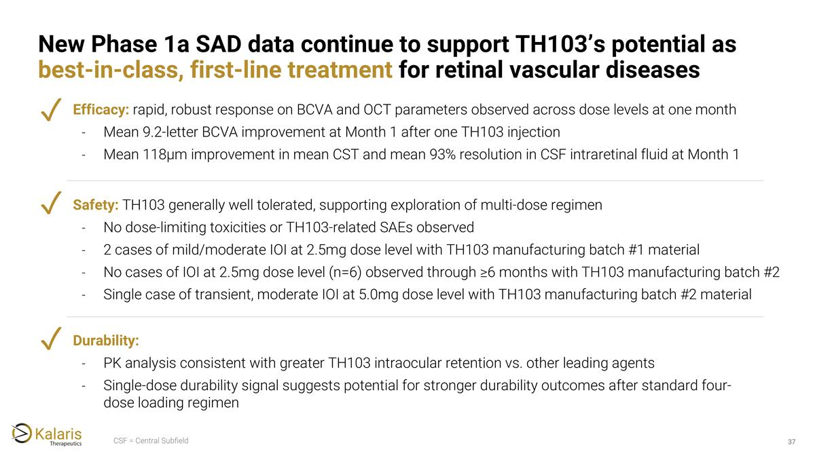
New Phase 1a SAD data continue to support TH103’s potential as best-in-class, first-line treatment for retinal vascular diseases CSF = Central Subfield Efficacy: rapid, robust response on BCVA and OCT parameters observed across dose levels at one month Mean 9.2-letter BCVA improvement at Month 1 after one TH103 injection Mean 118μm improvement in mean CST and mean 93% resolution in CSF intraretinal fluid at Month 1 ✓ Safety: TH103 generally well tolerated, supporting exploration of multi-dose regimen No dose-limiting toxicities or TH103-related SAEs observed 2 cases of mild/moderate IOI at 2.5mg dose level with TH103 manufacturing batch #1 material No cases of IOI at 2.5mg dose level (n=6) observed through ≥6 months with TH103 manufacturing batch #2 Single case of transient, moderate IOI at 5.0mg dose level with TH103 manufacturing batch #2 material ✓ Durability: PK analysis consistent with greater TH103 intraocular retention vs. other leading agents Single-dose durability signal suggests potential for stronger durability outcomes after standard four-dose loading regimen ✓


TH103 Ongoing Development Program

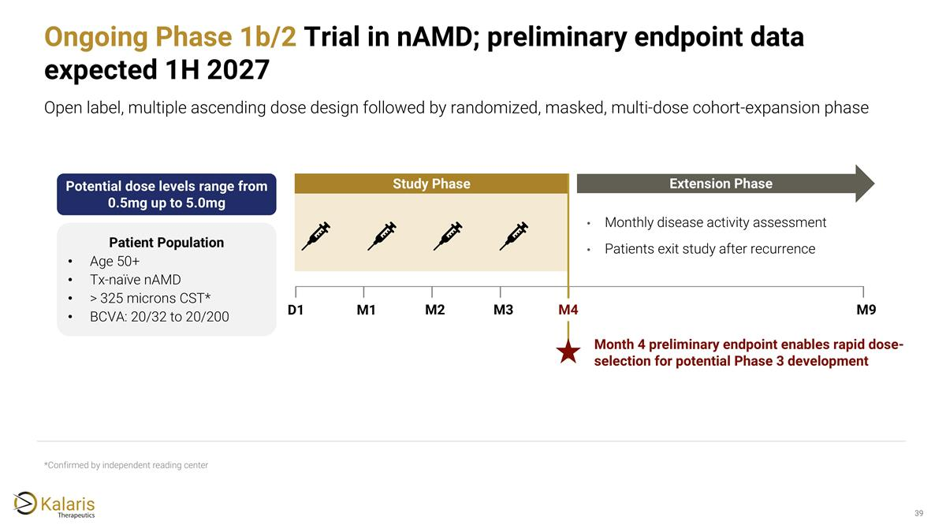
*Confirmed by independent reading center Ongoing Phase 1b/2 Trial in nAMD; preliminary endpoint data expected 1H 2027 Open label, multiple ascending dose design followed by randomized, masked, multi-dose cohort-expansion phase M1 M2 M3 M9 Study Phase Extension Phase Monthly disease activity assessment Patients exit study after recurrence M4 Month 4 preliminary endpoint enables rapid dose-selection for potential Phase 3 development D1 Patient Population Age 50+ Tx-naïve nAMD > 325 microns CST* BCVA: 20/32 to 20/200 Potential dose levels range from 0.5mg up to 5.0mg

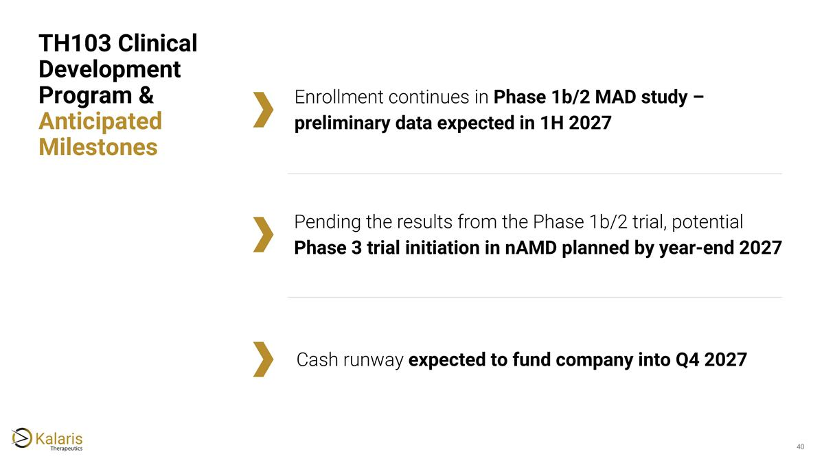
Cash runway expected to fund company into Q4 2027 TH103 Clinical Development Program & Anticipated Milestones Enrollment continues in Phase 1b/2 MAD study – preliminary data expected in 1H 2027 Pending the results from the Phase 1b/2 trial, potential Phase 3 trial initiation in nAMD planned by year-end 2027

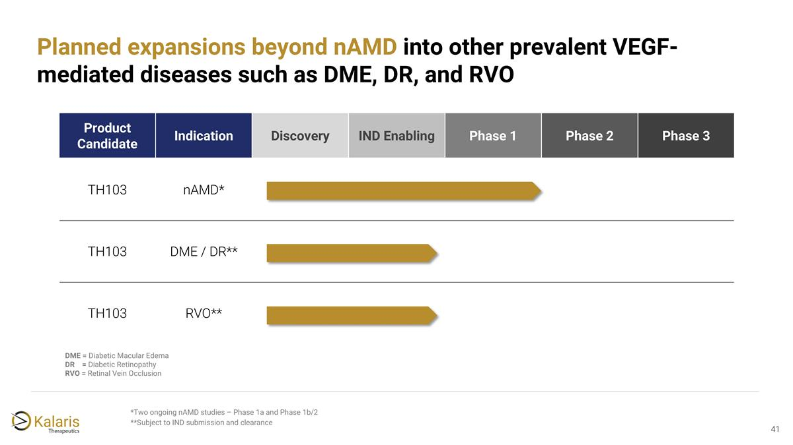
Product Candidate Indication Discovery IND Enabling Phase 1 Phase 2 Phase 3 TH103 nAMD* TH103 DME / DR** TH103 RVO** *Two ongoing nAMD studies – Phase 1a and Phase 1b/2 **Subject to IND submission and clearance Planned expansions beyond nAMD into other prevalent VEGF-mediated diseases such as DME, DR, and RVO DME = Diabetic Macular Edema DR = Diabetic Retinopathy RVO = Retinal Vein Occlusion


Corporate

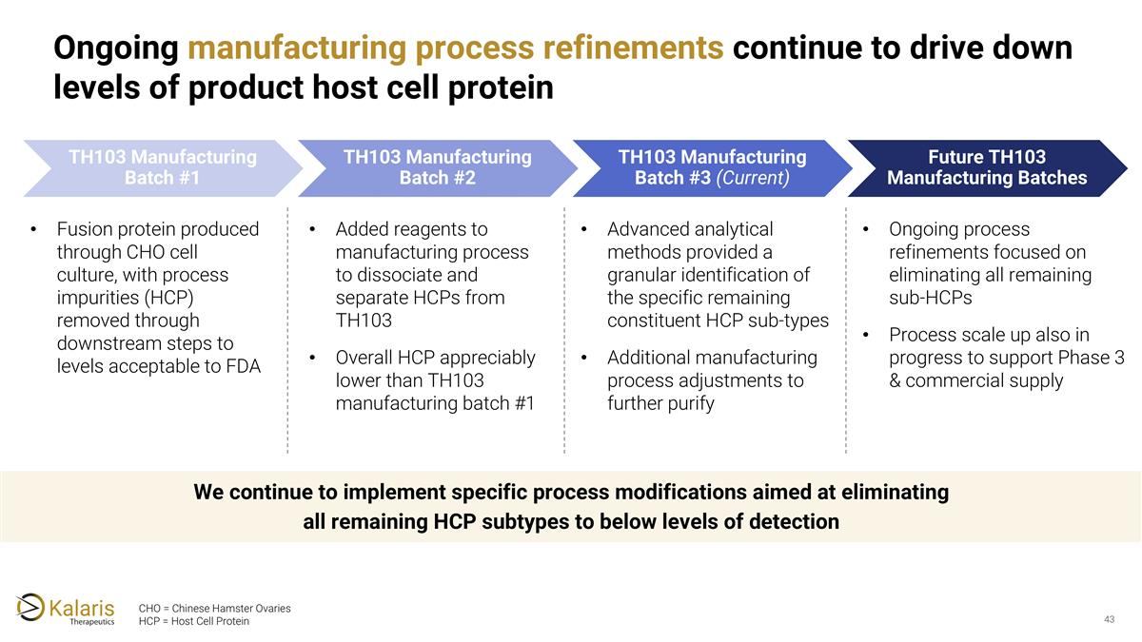
TH103 Manufacturing Batch #1 Fusion protein produced through CHO cell culture, with process impurities (HCP) removed through downstream steps to levels acceptable to FDA TH103 Manufacturing Batch #2 Added reagents to manufacturing process to dissociate and separate HCPs from TH103 Overall HCP appreciably lower than TH103 manufacturing batch #1 TH103 Manufacturing Batch #3 (Current) Advanced analytical methods provided a granular identification of the specific remaining constituent HCP sub-types Additional manufacturing process adjustments to further purify CHO = Chinese Hamster Ovaries HCP = Host Cell Protein We continue to implement specific process modifications aimed at eliminating all remaining HCP subtypes to below levels of detection Ongoing manufacturing process refinements continue to drive down levels of product host cell protein Future TH103 Manufacturing Batches Ongoing process refinements focused on eliminating all remaining sub-HCPs Process scale up also in progress to support Phase 3 & commercial supply

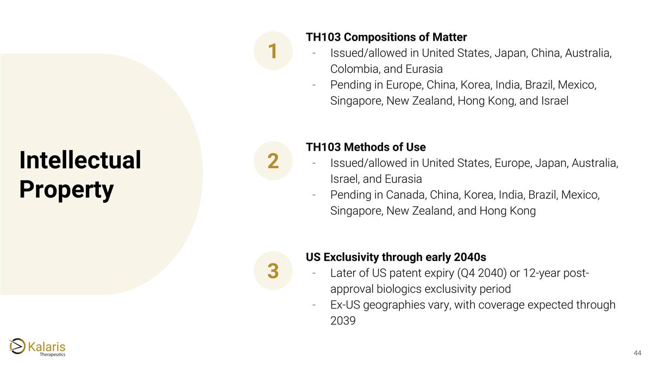
Intellectual Property TH103 Compositions of Matter Issued/allowed in United States, Japan, China, Australia, Colombia, and Eurasia Pending in Europe, China, Korea, India, Brazil, Mexico, Singapore, New Zealand, Hong Kong, and Israel 1 TH103 Methods of Use Issued/allowed in United States, Europe, Japan, Australia, Israel, and Eurasia Pending in Canada, China, Korea, India, Brazil, Mexico, Singapore, New Zealand, and Hong Kong 2 US Exclusivity through early 2040s Later of US patent expiry (Q4 2040) or 12-year post-approval biologics exclusivity period Ex-US geographies vary, with coverage expected through 2039 3

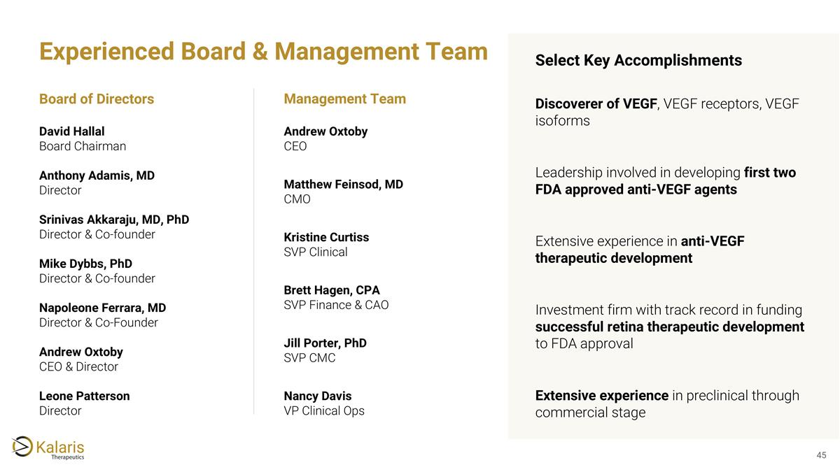
David Hallal Board Chairman Anthony Adamis, MD Director Srinivas Akkaraju, MD, PhD Director & Co-founder Mike Dybbs, PhD Director & Co-founder Napoleone Ferrara, MD Director & Co-Founder Leone Patterson Director Board of Directors Andrew Oxtoby CEO Matthew Feinsod, MD CMO Kristine Curtiss SVP Clinical Brett Hagen, CPA SVP Finance & CAO Jill Porter, PhD SVP CMC Nancy Davis VP Clinical Ops Management Team Discoverer of VEGF, VEGF receptors, VEGF isoforms Leadership involved in developing first two FDA approved anti-VEGF agents Extensive experience in anti-VEGF therapeutic development Investment firm with track record in funding successful retina therapeutic development to FDA approval Extensive experience in preclinical through commercial stage Select Key Accomplishments Experienced Board & Management Team Andrew Oxtoby CEO & Director

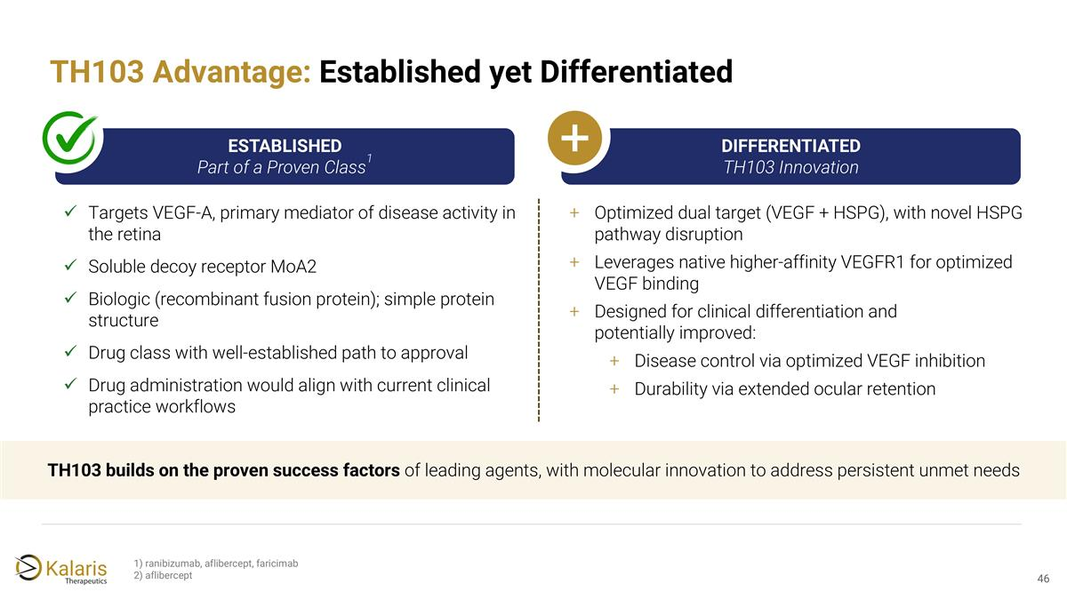
TH103 Advantage: Established yet Differentiated ESTABLISHED Part of a Proven Class1 Targets VEGF-A, primary mediator of disease activity in the retina Soluble decoy receptor MoA2 Biologic (recombinant fusion protein); simple protein structure Drug class with well-established path to approval Drug administration would align with current clinical practice workflows DIFFERENTIATED TH103 Innovation Optimized dual target (VEGF + HSPG), with novel HSPG pathway disruption Leverages native higher-affinity VEGFR1 for optimized VEGF binding Designed for clinical differentiation and potentially improved: Disease control via optimized VEGF inhibition Durability via extended ocular retention TH103 builds on the proven success factors of leading agents, with molecular innovation to address persistent unmet needs 1) ranibizumab, aflibercept, faricimab 2) aflibercept

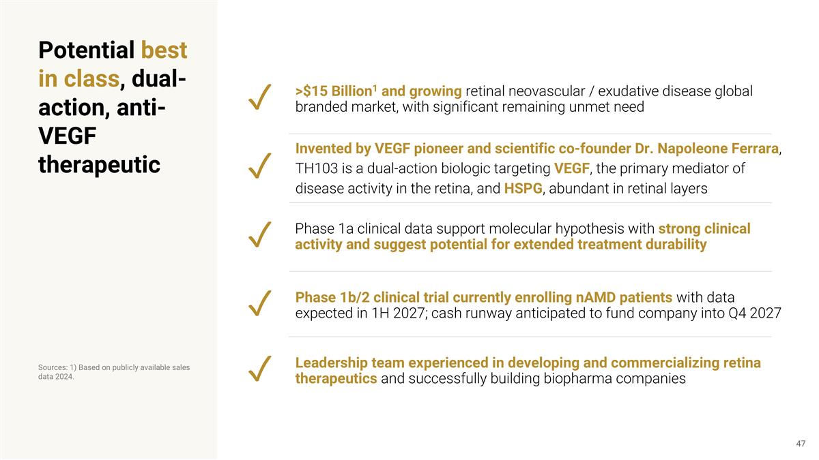
Invented by VEGF pioneer and scientific co-founder Dr. Napoleone Ferrara, TH103 is a dual-action biologic targeting VEGF, the primary mediator of disease activity in the retina, and HSPG, abundant in retinal layers Phase 1b/2 clinical trial currently enrolling nAMD patients with data expected in 1H 2027; cash runway anticipated to fund company into Q4 2027 ✓ >$15 Billion1 and growing retinal neovascular / exudative disease global branded market, with significant remaining unmet need ✓ ✓ ✓ Sources: 1) Based on publicly available sales data 2024. Phase 1a clinical data support molecular hypothesis with strong clinical activity and suggest potential for extended treatment durability Potential best in class, dual-action, anti-VEGF therapeutic Leadership team experienced in developing and commercializing retina therapeutics and successfully building biopharma companies ✓




Glossary

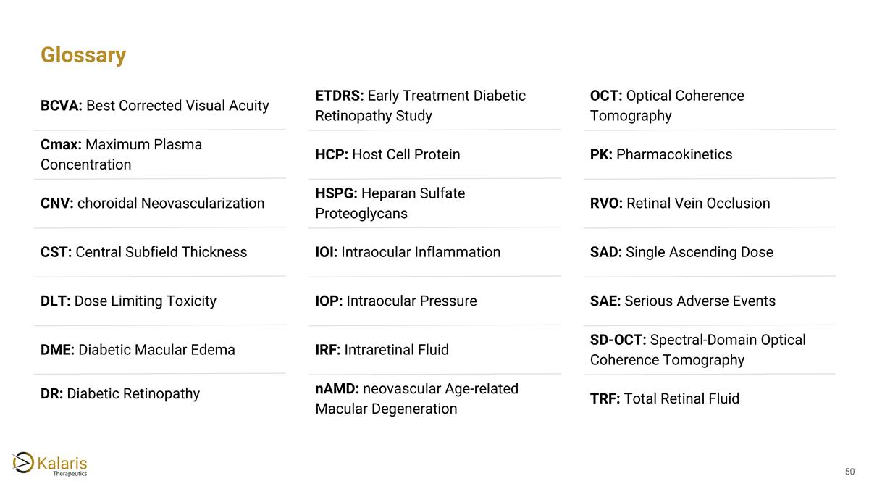
Glossary BCVA: Best Corrected Visual Acuity Cmax: Maximum Plasma Concentration CNV: choroidal Neovascularization CST: Central Subfield Thickness DLT: Dose Limiting Toxicity DME: Diabetic Macular Edema DR: Diabetic Retinopathy ETDRS: Early Treatment Diabetic Retinopathy Study HSPG: Heparan Sulfate Proteoglycans IOI: Intraocular Inflammation IOP: Intraocular Pressure IRF: Intraretinal Fluid nAMD: neovascular Age-related Macular Degeneration OCT: Optical Coherence Tomography PK: Pharmacokinetics RVO: Retinal Vein Occlusion SAD: Single Ascending Dose SAE: Serious Adverse Events SD-OCT: Spectral-Domain Optical Coherence Tomography TRF: Total Retinal Fluid HCP: Host Cell Protein


Anti-VEGF Therapeutics Background

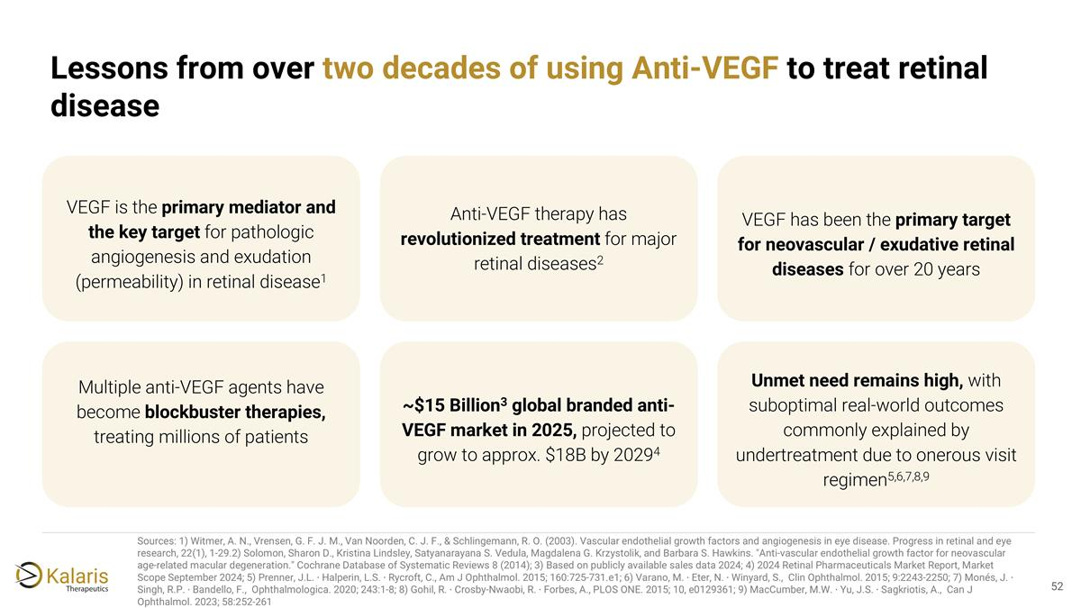
Sources: 1) Witmer, A. N., Vrensen, G. F. J. M., Van Noorden, C. J. F., & Schlingemann, R. O. (2003). Vascular endothelial growth factors and angiogenesis in eye disease. Progress in retinal and eye research, 22(1), 1-29.2) Solomon, Sharon D., Kristina Lindsley, Satyanarayana S. Vedula, Magdalena G. Krzystolik, and Barbara S. Hawkins. "Anti‐vascular endothelial growth factor for neovascular age‐related macular degeneration." Cochrane Database of Systematic Reviews 8 (2014); 3) Based on publicly available sales data 2024; 4) 2024 Retinal Pharmaceuticals Market Report, Market Scope September 2024; 5) Prenner, J.L. ∙ Halperin, L.S. ∙ Rycroft, C., Am J Ophthalmol. 2015; 160:725-731.e1​; 6) Varano, M. ∙ Eter, N. ∙ Winyard, S., ​ Clin Ophthalmol. 2015; 9:2243-2250​; 7) Monés, J. ∙ Singh, R.P. ∙ Bandello, F., ​ Ophthalmologica. 2020; 243:1-8​; 8) Gohil, R. ∙ Crosby-Nwaobi, R. ∙ Forbes, A., PLOS ONE. 2015; 10, e0129361​; 9) MacCumber, M.W. ∙ Yu, J.S. ∙ Sagkriotis, A., ​ Can J Ophthalmol. 2023; 58:252-261 Lessons from over two decades of using Anti-VEGF to treat retinal disease VEGF is the primary mediator and the key target for pathologic angiogenesis and exudation (permeability) in retinal disease1 Anti-VEGF therapy has revolutionized treatment for major retinal diseases2 VEGF has been the primary target for neovascular / exudative retinal diseases for over 20 years Multiple anti-VEGF agents have become blockbuster therapies, treating millions of patients ~$15 Billion3 global branded anti-VEGF market in 2025, projected to grow to approx. $18B by 20294 Unmet need remains high, with suboptimal real-world outcomes commonly explained by undertreatment due to onerous visit regimen5,6,7,8,9

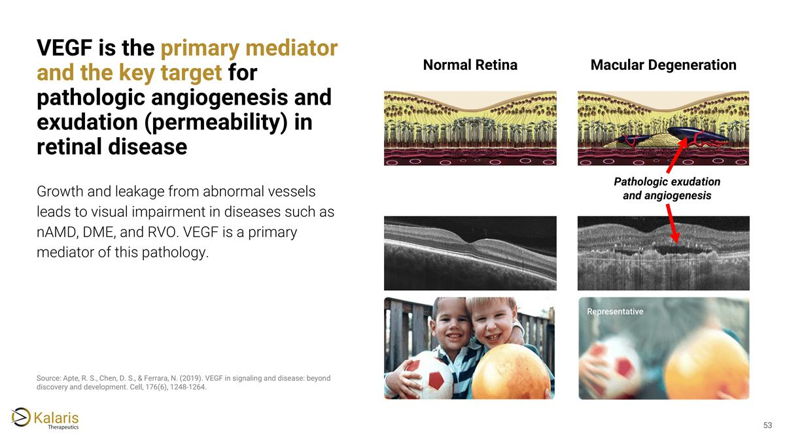
VEGF is the primary mediator and the key target for pathologic angiogenesis and exudation (permeability) in retinal disease Growth and leakage from abnormal vessels leads to visual impairment in diseases such as nAMD, DME, and RVO. VEGF is a primary mediator of this pathology. Source: Apte, R. S., Chen, D. S., & Ferrara, N. (2019). VEGF in signaling and disease: beyond discovery and development. Cell, 176(6), 1248-1264. Normal Retina Macular Degeneration Pathologic exudation and angiogenesis

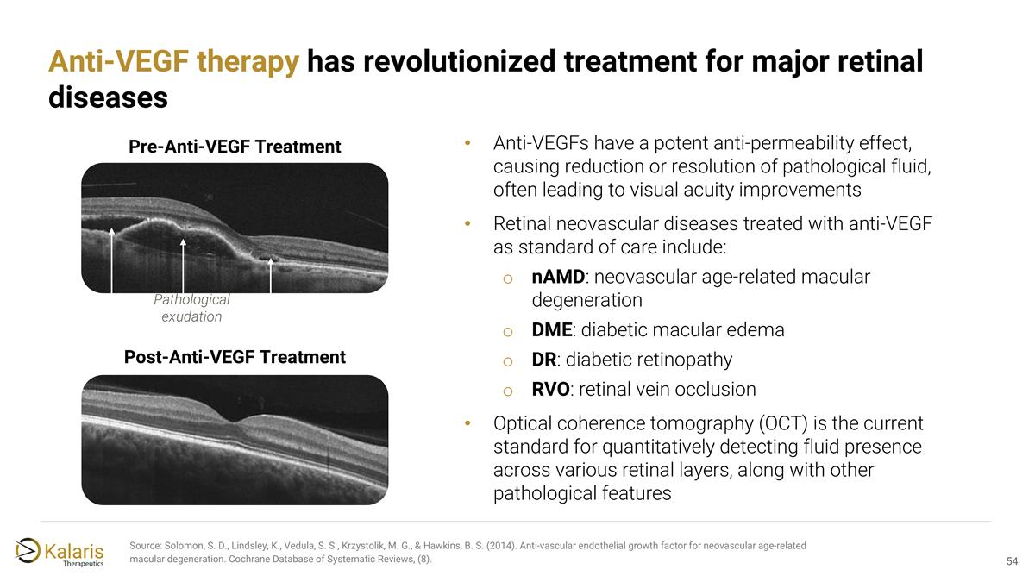
Anti-VEGF therapy has revolutionized treatment for major retinal diseases Source: Solomon, S. D., Lindsley, K., Vedula, S. S., Krzystolik, M. G., & Hawkins, B. S. (2014). Anti‐vascular endothelial growth factor for neovascular age‐related macular degeneration. Cochrane Database of Systematic Reviews, (8). Anti-VEGFs have a potent anti-permeability effect, causing reduction or resolution of pathological fluid, often leading to visual acuity improvements Retinal neovascular diseases treated with anti-VEGF as standard of care include: nAMD: neovascular age-related macular degeneration DME: diabetic macular edema DR: diabetic retinopathy RVO: retinal vein occlusion Optical coherence tomography (OCT) is the current standard for quantitatively detecting fluid presence across various retinal layers, along with other pathological features Post-Anti-VEGF Treatment Pre-Anti-VEGF Treatment Pathological exudation

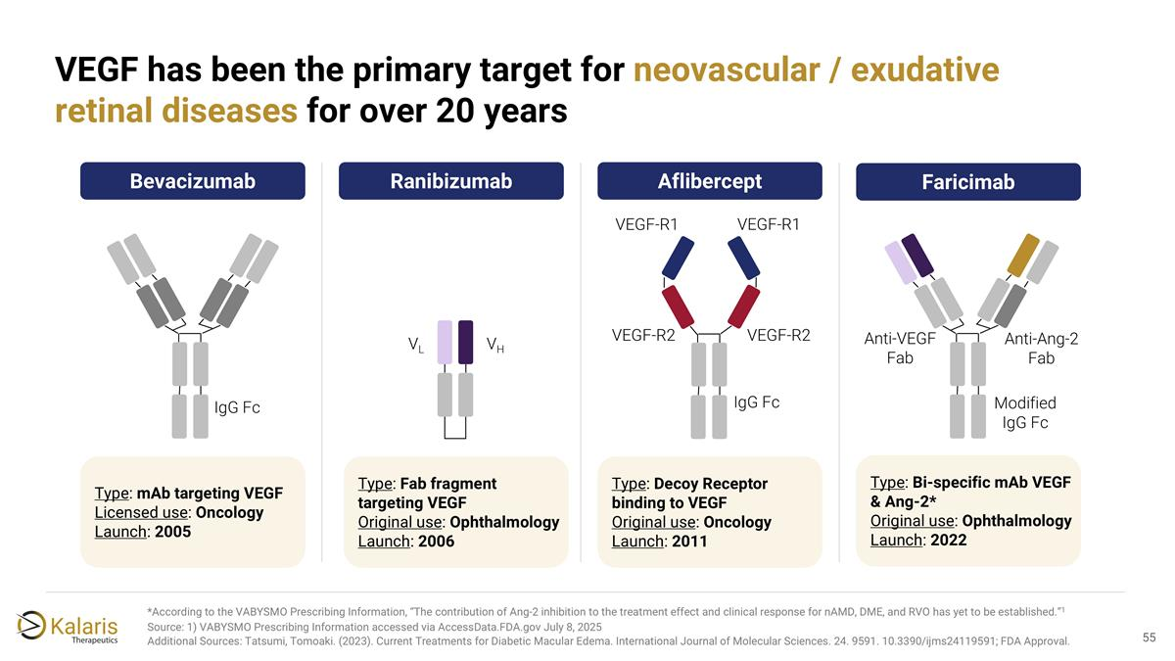
*According to the VABYSMO Prescribing Information, “The contribution of Ang-2 inhibition to the treatment effect and clinical response for nAMD, DME, and RVO has yet to be established.”1 Source: 1) VABYSMO Prescribing Information accessed via AccessData.FDA.gov July 8, 2025 Additional Sources: Tatsumi, Tomoaki. (2023). Current Treatments for Diabetic Macular Edema. International Journal of Molecular Sciences. 24. 9591. 10.3390/ijms24119591; FDA Approval. VEGF has been the primary target for neovascular / exudative retinal diseases for over 20 years VEGF-R2 VEGF-R2 VEGF-R1 VEGF-R1 VL VH IgG Fc Anti-VEGF Fab Anti-Ang-2 Fab Modified IgG Fc IgG Fc Bevacizumab Type: mAb targeting VEGF Licensed use: Oncology Launch: 2005 Ranibizumab Type: Fab fragment targeting VEGF Original use: Ophthalmology Launch: 2006 Aflibercept Type: Decoy Receptor binding to VEGF Original use: Oncology Launch: 2011 Faricimab Type: Bi-specific mAb VEGF & Ang-2* Original use: Ophthalmology Launch: 2022

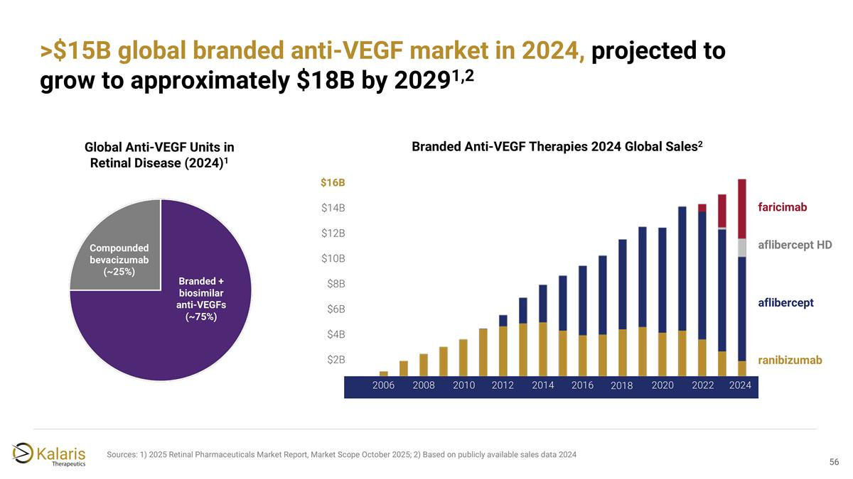
>$15B global branded anti-VEGF market in 2024, projected to grow to approximately $18B by 20291,2 Sources: 1) 2025 Retinal Pharmaceuticals Market Report, Market Scope October 2025; 2) Based on publicly available sales data 2024 Global Anti-VEGF Units in Retinal Disease (2024)1 Compounded bevacizumab (~25%) Branded + biosimilar anti-VEGFs (~75%) 2006 2008 2010 2012 2014 2016 2018 2020 2022 2024 $2B $4B $6B $8B $10B $12B $14B aflibercept ranibizumab faricimab aflibercept HD $16B Branded Anti-VEGF Therapies 2024 Global Sales2

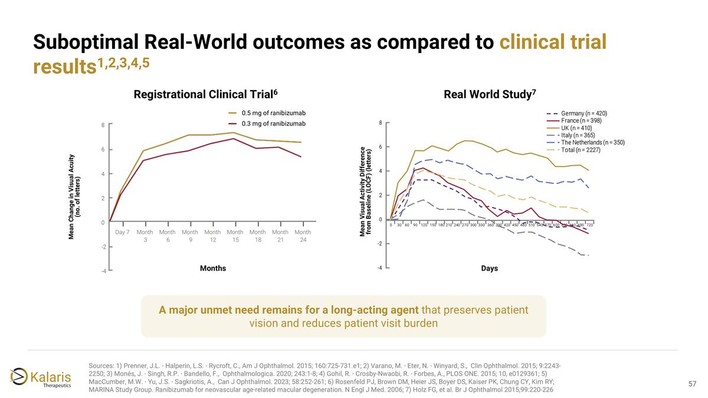
A major unmet need remains for a long-acting agent that preserves patient vision and reduces patient visit burden Real World Study7 Registrational Clinical Trial6 Days Mean Visual Activity Difference from Baseline (LOCF) (letters) Mean Change in Visual Acuity (no. of letters) Day 7 Month 3 Month 6 Month 9 Month 12 Month 15 Month 18 Month 21 Month 24 Months 0.5 mg of ranibizumab 0.3 mg of ranibizumab Suboptimal Real-World outcomes as compared to clinical trial results1,2,3,4,5 Sources: 1) Prenner, J.L. ∙ Halperin, L.S. ∙ Rycroft, C., Am J Ophthalmol. 2015; 160:725-731.e1​; 2) Varano, M. ∙ Eter, N. ∙ Winyard, S., ​ Clin Ophthalmol. 2015; 9:2243-2250​; 3) Monés, J. ∙ Singh, R.P. ∙ Bandello, F., ​ Ophthalmologica. 2020; 243:1-8​; 4) Gohil, R. ∙ Crosby-Nwaobi, R. ∙ Forbes, A., PLOS ONE. 2015; 10, e0129361​; 5) MacCumber, M.W. ∙ Yu, J.S. ∙ Sagkriotis, A., ​ Can J Ophthalmol. 2023; 58:252-261; 6) Rosenfeld PJ, Brown DM, Heier JS, Boyer DS, Kaiser PK, Chung CY, Kim RY; MARINA Study Group. Ranibizumab for neovascular age-related macular degeneration. N Engl J Med. 2006; 7) Holz FG, et al. Br J Ophthalmol 2015;99:220-226

